DDoS Analyzer
– AI-Based DDoS Attack Classification



Project ID: Fall25-42

Session: BSCS Fall 2022 to 2026

Project Advisor: Ma’am Namra Tahir

Submitted By

Huzaifa Zahid | 70132358
Shahmeer Abdullah | 70140615
Syed Ali Haider | 70126520

Department of Computer Science & IT
The University of Lahore
Lahore, Pakistan

Declaration

We have read the project guidelines and we understand the meaning of academic dishonesty, in particular plagiarism and collusion. We hereby declare that the work we submitted for our final year project, entitled DDoS Analyzer (AI-Based DDoS Attack Classification) is original work and has not been printed, published or submitted before as final year project, research work, publication or any other documentation.

Huzaifa Zahid
70132358

Signature: …………………………

Shahmeer Abdullah
70140615

Signature: …………………………

Syed Ali Haider
70126520

Signature: …………………………

Statement of Submission

This is to certify that Huzaifa Zahid (Roll No.70132358 ), Shahmeer Abdullah (Roll No.70140615) and Syed Ali Haider (Roll No.70126520 ) have successfully submitted the final project named as: DDoS Analyzer (AI-Based DDoS Attack Classification), at Computer Science & IT Department, The University of Lahore, Lahore Pakistan, to fulfill the partial requirement of the degree of BS in Computer Science.

Supervisor Name: Namra Tahir

Signature: …………………………
Date: ………………………

Dedication

As a matter of some importance, we devote our task to Allah Almighty. Also, to whom the world owes its presence Muhammad (Harmony Arrive). This unassuming exertion is committed to our adored guardians who brought us to the degree of greatness where we are reading up today searching generally speaking Promising and sparkling future ahead for which they scarified the majority of the time of their life & to our regarded and virtuoso instructors who directed us all through scholastic profession and that multitude of individuals who have recollected that us in their requests! A great deal of gratitude for every one of my instructors.

Acknowledgement

Above all, we owe a debt of gratitude to the Almighty God, who granted us a life of purpose and whom we thank for providing us with the strength and stamina to complete this task. The accomplishment and success of this project are the result of the hard work and dedication of numerous individuals who offered direct or indirect support, and we extend our sincere gratitude to all of them for their commitment. First, we would like to thank everyone who is reading this project for their time and interest. It has been a great pleasure to go through a challenging yet necessary learning experience.
Most importantly, we would like to express our deepest gratitude to our supervisor, Ma’am Namra Tahir, for her continuous support, patience, and guidance throughout the semester, as well as for sharing her knowledge and assisting us at every stage of the project’s development.
Last but not least, we would like to express our heartfelt gratitude and respect to our parents, whose love, care, and encouragement helped us progress academically and kept us motivated. We also owe a great debt of gratitude to our siblings, whose constant support provided us with the motivation needed to pursue and achieve our academic goals.
Additionally, we received significant support from our friends who were also working on their capstone projects, particularly through their emotional encouragement. We all faced challenges, and we managed to overcome them by supporting one another.
Finally, we are thankful to our friends and families whose silent yet unwavering support enabled us to successfully complete this project.

Date:
June 1, 2026

Abstract

DDoS Analyzer introduces an AI-powered platform designed to classify network traffic and identify Distributed Denial of Service attacks with improved accuracy and efficiency. The system focuses on interpreting patterns within traffic logs using machine learning, allowing users to analyze both current and previously recorded data. Unlike traditional monitoring tools that only detect threats in real time, this solution enables deeper investigation into past incidents, helping security teams uncover long term attack trends and strengthen their defense strategies.

The platform integrates core analytical features, including automated classification, visual representation of traffic behavior, and comparison of different machine learning approaches within a unified interface. By reducing the need for manual inspection and rule-based detection, the system enhances the speed and reliability of security analysis while offering clear insights into normal and malicious activity.

DDoS Analyzer addresses the limitations of conventional methods by providing an accessible, scalable, and intelligence-driven tool for threat analysis. Its contribution extends beyond detection, supporting cybersecurity professionals in decision making, improving preparedness, and fostering a more resilient digital environment.

Area of the Project

Artificial Intelligence, Machine Learning, Network Traffic Analysis, Web Application Development.

Technologies used

- Python
- Flask
- HTML
- CSS
- JavaScript
- Pandas
- NumPy
- Scikit-learn
- Joblib
- Scapy
- ReportLab
- Matplotlib / Chart-based visualizations
- Google Gemini API integration (optional)
- Wireshark and CICFlowMeter for lab dataset generation
- Kali Linux and Windows virtual machines for controlled traffic capture

List of Figures

Figure 1 Block Diagram – Product Perspective ...........................................................................10
Figure 2 Use Case – Upload Dataset ............................................................................................11
Figure 3 Use Case – View Results ...............................................................................................12
Figure 4 Use Case – Compare Model Performance .....................................................................13
Figure 5 Architecture Diagram ....................................................................................................14
Figure 6 Entity Relationship Diagram .........................................................................................15
Figure 7 Data Flow Diagram – Level 0 .......................................................................................16
Figure 8 Data Flow Diagram – Level 1 .......................................................................................17
Figure 9 Class Diagram ...............................................................................................................18
Figure 10 Aggregated Activity Diagram .....................................................................................19
Figure 11 Activity Diagram – Upload Dataset ............................................................................20
Figure 12 Activity Diagram – Model Training & Testing ...........................................................21
Figure 13 Activity Diagram – View Classification Results .........................................................22
Figure 14 Activity Diagram – Visualize Model Performance .....................................................23
Figure 15 Sequence Diagram – Upload Dataset ..........................................................................24
Figure 16 Sequence Diagram – Model Processing ......................................................................25
Figure 17 Sequence Diagram – Display Results .........................................................................26
Figure 18 Collaboration Diagram – Dataset Processing .............................................................27
Figure 19 Collaboration Diagram – Model Evaluation ...............................................................28
Figure 20 State Transition Diagram – Dataset Lifecycle ............................................................29
Figure 21 Component Diagram ...................................................................................................30
Figure 22 Deployment Diagram ..................................................................................................31
Figure 23 User Manual – Home / Dashboard Screen ..................................................................32
Figure 24 User Manual – Dataset Upload Screen .......................................................................33
Figure 25 User Manual – Dataset Loaded Confirmation ............................................................34
Figure 26 User Manual – Analyze Dataset Result Screen ..........................................................35
Figure 27 User Manual – Traffic Distribution Chart ..................................................................36
Figure 28 User Manual – Model Performance Comparison .......................................................37
Figure 29 User Manual – Recommendations Section .............................................................38
Figure 30 User Manual – JSON / CSV Export Output ...........................................................39
Figure 31 User Manual – Generated PDF Report ...................................................................40
Figure 32 User Manual – Settings Screen ...............................................................................41
Figure 33 User Manual – PCAP-to-CSV Utility .....................................................................42

List of Tables

Table 1 Functional Requirement Dataset Upload ...................................................................... 11
Table 2 Functional Requirement Data Preprocessing ................................................................12
Table 3 Functional Requirement Model Training ............................................................... …..12
Table 4 Functional Requirement Traffic Classification ............................................................ 13
Table 5 Functional Requirement Visualization and Analytics ............................................. ….13
Table 6 Functional Requirement Report Export .........................................................................14
Table 7 Use Case – Upload Dataset ...........................................................................................18
Table 8 Use Case – Preprocess Dataset ......................................................................................19
Table 9 Use Case – Train Model ............................................................................................... 20
Table 10 Use Case – Classify Traffic ........................................................................................ 21
Table 11 Use Case – Visualize Results ......................................................................................22
Table 12 Use Case – Generate Report ........................................................................................23
Table 13 Data Dictionary of ERD ..............................................................................................28
Table 14 Positive Test Case – CSV Upload ...............................................................................49
Table 15 Negative Test Case – Invalid File Upload ...................................................................50
Table 16 Positive Test Case – PCAP Conversion ......................................................................51
Table 17 Negative Test Case – Empty PCAP ............................................................................52
Table 18 Negative Test Case – No Recognizable Features ........................................................53
Table 19 Positive Test Case – PDF Export ................................................................................54
Table 20 Equivalence Partitioning .............................................................................................55
Table 21 Boundary Value Analysis ............................................................................................56
Table 22 Decision Table Testing ................................................................................................57
Table 23 State Transition Testing ...............................................................................................58
Table 24 Use Case Testing .........................................................................................................59
Table 25 Cyclomatic Complexity Analysis ................................................................................60
Table 26 Performance Testing ....................................................................................................61
Table 27 Stress Testing ...............................................................................................................62
Table 28 System Testing Coverage ............................................................................................63
Table 29 Regression Testing Coverage ......................................................................................64
Table 30 Tools and Techniques ..................................................................................................65
Table 31 Appendix A – System Requirements ...........................................................................78
Table 32 Appendix B – Example API Endpoints .......................................................................79
Table 33 Appendix C – Current Model Artifacts .......................................................................80
Table 34 Appendix D – Supported Dataset Formats ..................................................................81

Table of Content

Declaration i
Statement of Submission ii
Dedication iii
Acknowledgement iv
Abstract v
List of Figures vii
List of Tables ix
Chapter 1: Introduction to the Problem 1
Chapter 2: Software Requirement Specification 6
System Interfaces 8
User Interfaces 8
Hardware Interfaces 9
Software Interfaces 10
Communications Interfaces 10
Memory Requirements 10
Operations 10
Site Adaptation Requirements 10
Chapter 3: Use Case Analysis 18
Chapter 4: Design 24
Chapter 5: Testing 50
Chapter 6: Tools and Techniques 59
Chapter 7: Summary and Conclusion 61
Chapter 8: User Manual 62
Chapter 9: Lessons Learnt and Future Work 68
References 69
Books 69
Book Chapters 69
Journal Articles 69
Conference Papers 70
Online Documents / Datasets 70
Websites 70
APPENDIX 82
Appendix A – System Requirements 82
Appendix B – DDoS Attack Types (Sample) 82
Appendix C – Example API Endpoints 83
Appendix D – Dataset Description (CIC-DDoS2019) 83
Appendix E – Linux & Kali Tools Used 84
Chapter 10 85
Experimental Testbed and Custom Traffic Dataset Generation Using Kali Linux and CICFlowMeter 85
10.1 Introduction 85
10.2 Why CIC DDoS 2019 Dataset Format Was Chosen 85
10.3 Tools and Environment Used 86
10.4 Network Configuration and Connectivity Verification 88
10.5 Service Setup for HTTP Based Traffic 91
10.6 Attack Traffic Generation Scenarios Used 93
10.7 Traffic Capture Process on Windows 97
10.8 Converting PCAP to CSV Using CICFlowMeter Offline Mode 98
10.9 Summary of Chapter 100

Chapter 1: Introduction to the Problem

Introduction

In the modern digital age, network security has become a critical concern with the increasing frequency and sophistication of cyberattacks. Distributed Denial of Service (DDoS) attacks, in particular, pose a significant threat to the availability and reliability of online services, affecting organizations, governments, and individuals. Traditional network monitoring methods, such as manual traffic inspection and rule-based intrusion detection systems, often struggle to detect complex, multi-vector attacks efficiently. The growing volume of network traffic, combined with the diversity of attack types, highlights the need for intelligent, automated solutions capable of analyzing and classifying malicious activity.
Existing tools for DDoS detection are often costly, hardware-dependent, or require advanced cybersecurity expertise, which limits accessibility for smaller organizations, educational institutions, and individual network administrators. Many solutions focus on real-time monitoring, leaving little support for batch processing or historical traffic analysis, which are critical for understanding attack trends and developing long-term mitigation strategies. This creates a gap for an accessible, user-friendly, and automated system that can analyze traffic data efficiently and provide actionable insights.
The proposed project, DDoS Analyzer – AI-Based DDoS Attack Classification, addresses these challenges by developing an open-source platform that allows users to upload network traffic datasets for analysis [6], [7]. The system preprocesses the data, applies supervised machine learning models, and classifies normal and malicious traffic, including various DDoS attack types [9]. Graphical visualizations are generated to illustrate traffic distribution, attack patterns, and model performance, making it easier for users to interpret results without requiring extensive cybersecurity knowledge [13].
DDoS Analyzer removes the need for specialized infrastructure or real-time monitoring, making it widely accessible for network administrators, IT security analysts, and students. The platform supports offline analysis, model comparison, and detailed insights into malicious activity, enabling proactive measures for network protection. By providing a cost-effective, automated, and intuitive solution, DDoS Analyzer addresses the growing demand for intelligent cybersecurity tools capable of analyzing modern network threats efficiently [14].

Purpose

In the modern digital era, DDoS attacks are among the most frequent and disruptive cybersecurity threats, causing service outages, operational losses, and reputational damage to organizations. Traditional security tools primarily rely on real-time traffic monitoring, which only detects threats as they occur and fails to provide insights into historical attack patterns. This limitation makes it difficult for security teams to analyze past incidents, identify vulnerabilities, and refine long-term defense strategies. There is a clear need for an intelligent, accessible tool that can process both current and historical network traffic to uncover patterns and enhance cybersecurity preparedness.

The DDoS Analyzer project addresses this need by developing an AI-based platform that enables automated classification of network traffic datasets. Users can upload traffic logs, which are then preprocessed, analyzed, and classified as normal or malicious using supervised machine learning models. The system also provides batch processing capabilities, allowing organizations to study past network traffic, detect previously unnoticed attack patterns, and improve the efficiency of their threat detection processes.

By offering visual representations of traffic analysis and model performance, the platform makes it easier for users to interpret results and make informed decisions. The comparison of different machine learning models helps determine the most effective approach for specific network environments, reducing reliance on manual inspection and minimizing errors. With a user-friendly web interface, DDoS Analyzer ensures that both technical and non-technical users can access actionable insights without needing advanced cybersecurity expertise.

From a societal perspective, the project empowers cybersecurity analysts, network administrators, and smaller organizations to strengthen their defenses against DDoS attacks. By providing affordable, open-source, and automated analytical tools, it reduces manual effort, supports offline investigation, and enables informed decision-making for both immediate and long-term security improvements. The system contributes to a safer, more resilient digital ecosystem by helping organizations proactively understand, respond to, and mitigate the impact of network attacks.

Objective

The objective of the DDoS Analyzer project is to develop an AI-based network traffic analysis platform that enables automated detection and classification of DDoS attacks while providing actionable insights for cybersecurity teams:

- Allow users to upload both current (just captured datasets) and historical (six months or older) network traffic datasets for analysis.
- Classify traffic into normal or malicious (DDoS) using supervised machine learning models with high accuracy.
- Support batch processing of traffic logs to study past incidents and identify hidden attack patterns.
- Provide visual representations of detection results, including traffic distribution and model performance graphs.
- Enable comparison of different machine learning models to determine the most effective detection approach.
- Offer a user-friendly web interface for uploading datasets, visualizing results, and accessing insights easily.
- Minimize manual effort by eliminating the need for packet-by-packet inspection.
- Facilitate long-term cybersecurity strategy improvement by uncovering trends in historical traffic data.
- Empower network administrators and security analysts to make informed decisions and strengthen defenses.
- Ensure the solution is cost-effective and accessible for organizations and individuals without requiring specialized infrastructure.

Existing Solution
Several network security tools exist in the market for analyzing and detecting DDoS attacks. However, these solutions often focus on real-time traffic monitoring or signature-based detection, which limits their ability to analyze historical data and uncover long-term attack patterns.
Existing Solutions and Their Limitations:
- Wireshark:
  - Provides manual packet inspection and supports a wide range of network protocols
  - Offers real-time and offline traffic analysis but requires technical expertise for accurate interpretation [1], [13].
  - Limited automation for classifying DDoS attacks, relying heavily on user intervention [12].
- Snort:
  - Uses signature-based detection to identify threats in real-time traffic [14].
  - Provides rule-based alerts and integrates with SIEM tools for enterprise networks .
  - Cannot analyze historical logs or automatically classify traffic, limiting its utility for long-term attack trend analysis [8], [9].
Problems with Existing Solutions:
- Limited Historical Analysis: Most tools focus on live monitoring and fail to provideinsights into past incidents.
- High Manual Effort: Manual inspection of packets or logs is time-consuming and error-prone.
- Dependence on Signatures or Rules: Tools like Snort may miss evolving or unknown attack patterns due to reliance on predefined signatures.
- Accessibility: Many solutions require advanced technical knowledge, restricting use by smaller organizations or educational purposes.
How DDoS Analyzer Addresses These Issues:
DDoS Analyzer is an AI-powered, open-source platform that classifies network traffic using machine learning models. Unlike existing solutions, it can process both current and historical traffic datasets, detect DDoS attacks automatically, and provide visual analytics for better understanding. By eliminating the need for manual inspection and signature dependency, the platform enhances efficiency and accessibility, enabling network administrators and security teams to uncover hidden attack patterns and improve long-term defenses. To the best of our knowledge, no tool currently available provides automated DDoS classification using machine learning for both historical and
current traffic in a user-friendly, open-source solution.

Proposed Solution
To address the limitations of existing network security tools, the DDoS Analyzer introduces an AI-powered platform that enables automated classification and analysis of network traffic datasets. Unlike traditional tools such as Wireshark or Snort, which rely on manual inspection or signature-based detection, DDoS Analyzer provides a cost-effective, user-friendly, and open-source solution capable of analyzing both current and historical traffic logs.

Key Aspects of the Proposed Solution:
- AI-Powered Traffic Classification – Uses supervised machine learning models to accurately classify network traffic as normal or DDoS, reducing reliance on manual inspection and signature-based rules.
- Batch Processing of Traffic Logs – Supports the analysis of historical datasets, enabling security teams to study past incidents, identify attack patterns, and improve long-term defense strategies.
- Visual Analytics and Model Comparison – Provides graphical representations of detection results and compares performance across different machine learning models, helping users understand which approach works best for their environment.

- User-Friendly Web Interface – Simplifies dataset uploads, visualization of results, and access to actionable insights, making the tool accessible to both technical and non-technical users.
- Enhanced Accessibility and Efficiency – Eliminates the need for packet-by-packet inspection, reducing manual effort while improving detection accuracy and operational efficiency.
- Comprehensive Security Insights – Provides actionable recommendations to refine firewall rules, update detection policies, and strengthen network defenses based on historical and current traffic analysis.
- Scalable and Future-Ready – Designed to integrate additional machine learning models and adapt to evolving cyber threats, ensuring long-term usability and technological relevance.

Chapter 2: Software Requirement Specification

Introduction

Purpose
The purpose of the DDoS Analyzer – AI-Based DDoS Attack Classification project is to provide a machine learning powered web application that analyzes uploaded network traffic datasets and accurately classifies DDoS and normal traffic, addressing the limitations of manual log inspection and traditional signature based tools. This SRS defines the system’s complete functional and non functional requirements, ensuring a clear and unified understanding for developers, supervisors, evaluators, and cybersecurity analysts, while serving as a technical guide throughout the development process to keep the final product aligned with the project’s goals and scope.

Scope

The software product to be developed is DDoS Analyzer (AI-Based DDoS Attack Classification), a web-based analytical tool that processes uploaded network traffic datasets to classify normal and malicious traffic accurately. The system will support batch-based detection, allowing users to upload offline datasets rather than relying on real-time packet capture. It will preprocess the data, train machine learning models such as Random Forest, and generate comparative performance metrics, including accuracy scores and visual analytics. The tool will provide a clear summary of classified traffic, highlighting the percentage of normal and DDoS attack flows, while offering graphs and charts that help users interpret the results easily.

The system will not perform live, real-time traffic monitoring, nor will it automate network mitigation. Instead, it focuses entirely on offline analysis, supervised model training, dataset evaluation, and visualization of results. The software is intended for cybersecurity analysts, students, and network administrators who need an accessible platform for incident analysis and long-term threat assessment using historical logs. It delivers clear benefits such as reduced manual inspection, improved attack classification accuracy, and an integrated environment for model comparison. The scope aligns with the higher-level project goals stated in the proposal, ensuring that the system contributes to better intrusion analysis, enhanced understanding of network behavior patterns, and improved cybersecurity decision-making.

Definitions, acronyms, and abbreviations

• AI (Artificial Intelligence): The capability of computer systems to perform tasks that typically require human intelligence, including pattern recognition and automated decision making.
• ML (Machine Learning): A branch of AI that enables systems to learn from data and improve classification accuracy without explicit programming.
• DDoS (Distributed Denial of Service): A cyberattack in which multiple compromised systems flood a network or server with traffic, disrupting normal service.
• NIDS (Network Intrusion Detection System): A security tool that monitors network traffic to identify malicious activity or policy violations.
• CICIDS 2019: A publicly available intrusion detection dataset widely used for research in attack classification and network anomaly detection.
• Dataset: A structured collection of network traffic records used for model training, testing, and evaluation.
• Preprocessing: The cleaning and preparation of raw network traffic data, including normalization and feature extraction, before training an ML model.
• Classification Model: A machine learning model that assigns traffic records to categories such as normal or DDoS.
• Flask: A lightweight Python web framework used to develop the DDoS Analyzer’s interface and backend logic.
• Dashboard: A web interface where users upload datasets, view results, compare models, and analyze visual outputs.
• Accuracy: A performance metric indicating how often the ML model correctly classifies network traffic.
• Confusion Matrix: A table that displays the number of correct and incorrect predictions made by a classification model.
• ERD (Entity Relationship Diagram): A visual representation of the database structure defining entities and their relationships.
• API (Application Programming Interface): A set of protocols that allows software components to communicate within the system.
• Normalization: A preprocessing technique that scales dataset values into a consistent range to improve model performance.
• Batch Processing: The ability to process stored datasets instead of analyzing real-time traffic, allowing offline incident analysis.
• SRS (Software Requirements Specification): A structured document describing the functional, non-functional, and technical requirements of the system.

Overall description

Product perspective
The DDoS Analyzer is an independent and self-contained web application that uses machine learning to classify network traffic as normal or malicious. It processes uploaded datasets instead of relying on live traffic, which makes it suitable for offline analysis, research environments, and batch incident investigation. The system is built with Python and Flask, it integrates data preprocessing, feature extraction, model training, model comparison, and visualization within a single platform. The product requires only a web browser and locally stored datasets, allowing cybersecurity analysts and network administrators to analyze historical traffic logs without depending on external tools. The system provides an interactive dashboard, graphical analytics, and modular components for dataset upload, preprocessing, machine learning classification, and reporting. It stands apart because no such unified, affordable, and AI-based batch analysis tool is commonly available for students or small organizations.

System Interfaces
The DDoS Analyzer interacts with system components through:
• File upload interface for CSV or processed CICIDS/CICDDoS datasets,
• Flask backend endpoints for preprocessing, model training, prediction, and visualization,
• Machine learning modules such as Random Forest or other classifiers implemented in Python,
• Matplotlib and other libraries for generating performance graphs,
• Internal APIs that connect the front-end dashboard to backend classification functions.
The system supports integration with:
• Dataset management and preprocessing pipelines,
• Batch-based traffic classification modules,
• Real-time progress updates during model training,
• Downloadable results and logs for later use.

User Interfaces
The user interface is designed to remain simple, responsive, and beginner friendly. Major UI components include:
Dashboard
• Overview of all modules including dataset upload, preprocessing, model training, classification, and analytics,
• Summary widgets showing processed files and detection results.
Dataset Upload Page
• Upload window for CSV
• Validation checks to ensure correct format.
Preprocessing Module
• Options for cleaning, encoding, normalization, and feature selection,
• Preview of processed datasets.
Model Training and Testing Module
• Selection of machine learning algorithms,
• Display of accuracy, precision, recall, confusion matrix, and model comparison.
Analytics and Visualization Module
• Graphs showing normal vs malicious traffic distribution,
• Feature importance charts,
• Performance plots for each trained model.
Reports Page
• Exportable results in CSV or image format,
• Summary of detected DDoS or related attack categories.

Hardware Interfaces
• Requires a standard computer capable of running Python and Flask,
• Minimum 4GB RAM recommended for dataset processing,
• Dual-core processor or better for training ML models,
• Optional GPU support for faster training.

Software Interfaces
• Developed using Python, Flask, Scikit-learn, Pandas, and Matplotlib,
• Frontend built with HTML, CSS, JavaScript, Flask or similar,
• Supports integration with Jupyter-based workflows for dataset testing,
• Compatible with CICFlowMeter formatted datasets and standard CSV logs.

Communications Interfaces
• Localhost access over HTTP for normal operation,
• Optional HTTPS support if deployed on a server,
• Internal communication between frontend and backend through REST APIs.

Memory Requirements
• Minimum 4GB RAM for dataset preprocessing and ML training,
• Approximately 1GB secondary storage for saved datasets, models, and generated results.

Operations
• Normal operations include dataset upload, preprocessing, training, and classification,
• Special operations include exporting reports, comparing multiple models, and analyzing custom datasets,
• Option for saving trained models for future predictions.

Site Adaptation Requirements
• Configuration based on dataset structure such as CICIDS or custom logs,
• Adjustable preprocessing settings depending on network environment,
• Custom thresholds or sensitivity settings for different organizations or academic use.

Product functions

Dataset Upload
ID: | FR_01
Name: | Dataset Upload
Description | Input | Output | Requirements | Basic Workflow
Allow users to upload network traffic datasets for analysis | CSV file, CICIDS formatted dataset | Dataset successfully uploaded and stored for preprocessing and analysis | Correct dataset format | User selects the dataset file and clicks Upload. System validates the file and saves it.

Table 1 Functional Requirement Dataset Upload
PCAP Conversion
ID: | FR_02
Name: | PCAP Conversion
Description | Input | Output | Requirements | Basic Workflow
Convert uploaded packet capture into CIC-style | PCAP file | Flow-based CSV | Correct file format | System parses TCP/UDP flows and writes a CSV
Table 2 Functional Requirement Dataset Upload

Data Preprocessing
ID: | FR_03
Name: | Data Preprocessing
Description | Input | Output | Requirements | Basic Workflow
Clean, encode, normalize, and prepare dataset before model training | Uploaded dataset, preprocessing options such as encoding, normalization, feature selection | Preprocessed dataset with selected transformations applied | Proper dataset upload and valid preprocessing configuration | User selects preprocessing options and clicks Process. System applies preprocessing and prepares the dataset.

Table 3 Functional Requirement Data Preprocessing
Model Training
ID: | FR_04
Name: | Model Training
Description | Input | Output | Requirements | Basic Workflow
Automatically train multiple predefined machine learning models such as Random Forest, SVM, or Gradient Boosting, and compare their performance | Preprocessed dataset | Ranked model results showing accuracy, precision, recall, confusion matrix, and the best performing model | Sufficient RAM and CPU, correct preprocessing applied | System automatically trains all predefined models, compares their performance, and displays the model ranking and metrics

Table 4 Functional Requirement Model Training
Traffic Classification
ID: | FR_05
Name: | Traffic Classification
Description | Input | Output | Requirements | Basic Workflow
Classify network traffic as normal or malicious using the best performing trained model | Trained ML models and test dataset or uploaded dataset | Prediction results showing normal versus malicious traffic, including DDoS categories | Preprocessed dataset and trained models availability | User uploads or selects dataset, system runs classification using the best performing model and displays results

Table 5 Functional Requirement Traffic Classification

Visualization and Analytics
ID: | FR_06
Name: | Visualization and Analytics
Description | Input | Output | Requirements | Basic Workflow
Generate graphs showing traffic distribution, model performance, and key insights | Processed dataset, model performance metrics, and feature importance | Graphs for traffic distribution, feature importance, confusion matrix, and comparison graphs | Dataset must be preprocessed and models trained | User selects visualization type, system generates graphs such as bar charts, pie charts, or line plots.
Table 6 Functional Requirement Visualization and Analytics
Report Export
ID: | FR_07
Name: | Report Export
Description | Input | Output | Requirements | Basic Workflow
Export results, graphs, and model summary in a downloadable format | Classification results, graphs, performance metrics | Downloadable report in CSV or image format | Completed classification and generated graphs | User clicks Export, system generates the file for download.

Table 7 Functional Requirement Report Export

User characteristics

The intended users of the DDoS Analyzer system include cybersecurity analysts, network administrators, SOC team members, university students, researchers, and instructors involved in teaching or studying network security. These users generally have a basic to advanced educational background in computing or cybersecurity, along with varying levels of technical expertise. The system is designed to be intuitive and accessible, yet users benefit from having a foundational understanding of network traffic concepts and dataset formats. Users should be able to navigate web-based dashboards, interpret analytical results, and understand system-generated model summaries.

Key user characteristics include:
- Users should have access to a computer or laptop capable of running a web application with a stable internet connection.
- A basic understanding of cybersecurity concepts, network traffic features, and common attack behaviors enhances the usage experience.
- Users should be comfortable performing simple tasks such as dataset upload, viewing classification reports, and interpreting graphical outputs.
- Users may require familiarity with using datasets like CICIDS or CICDDoS and understanding the meaning of model performance metrics.

Constraints

- Must comply with cybersecurity data handling regulations and maintain ethical use of
network traffic datasets.
- Requires stable hardware resources such as sufficient RAM and CPU to support preprocessing and machine learning model training.

- Utilizes Flask or a Python based web framework to deliver system functionality through a browser interface.

- Dataset compatibility is limited to formats aligned with CICIDS or CICDDoS datasets for correct preprocessing and feature extraction.

- Supports parallel operations such as preprocessing, model comparison, and result generation to maintain efficient workflow.

- Includes audit logging features to record model evaluations, dataset uploads, and system-generated results for traceability.

- Maintains accuracy requirements for model comparison to ensure fair ranking of trained classifiers.

- Implements encrypted dataset handling and adheres to security best practices to protect sensitive traffic logs and user inputs.

- System workflow is dependent on machine learning operations, meaning performance may vary based on dataset size and system hardware.

Assumptions and dependencies

- Users will have access to stable computing resources capable of running the web interface and handling moderate-size datasets.
- The application will operate through modern web browsers such as Chrome, Firefox, or Edge with JavaScript enabled.
- Users will upload datasets in compatible formats, allowing the system to preprocess and analyze them without manual data correction.
- Model training and classification results rely on the availability of Python libraries such as Scikit-learn, Pandas, NumPy, and Matplotlib.
- The accuracy and speed of the system depend on the hardware specifications of the server or machine hosting the application.
- Backend services, dataset storage paths, and model directories must remain functional and properly configured.
- The training process assumes consistency in feature structure across datasets modeled after CICIDS and CICDDoS.
- System performance and model ranking accuracy depend on the availability and stability of underlying machine learning packages.

Apportioning of requirements

- Real time detection and live traffic monitoring may be considered for future versions, while the initial release focuses on batch processing only.
- Integration with SIEM tools or enterprise dashboards can be added in later updates to increase system compatibility with SOC environments.
- Support for additional machine learning models or deep learning architectures may be included in future versions to enhance detection accuracy.
- Automated report emailing and external alert notifications may be implemented in later releases based on user needs.
- Multi dataset comparison features and detailed feature engineering modules may be extended in future updates.

Specific requirements

This section describes the functional and non functional requirements of the DDoS Analyzer system at a level detailed enough for designers to create the system and testers to verify that the software meets all defined requirements.

Functional Requirement

This subsection outlines the main functional modules that form the core of the DDoS Analyzer system. These functions address the primary needs of users and support the system’s objective of detecting and classifying DDoS traffic using uploaded datasets.

- Dataset Upload:
Allows users to upload network traffic datasets in compatible formats so the system can begin the analysis process.
- Data Preprocessing:
Cleans the uploaded dataset, applies normalization, and prepares features needed for accurate machine learning model training.
- Model Training:
Automatically trains predefined machine learning models, evaluates their performance, and generates a ranked comparison of results.
- Traffic Classification:
Uses the best performing trained model to classify uploaded traffic as normal or malicious, including specific DDoS categories.
- Visualization and Analytics:
Create charts and visual summaries that explain dataset distribution, attack patterns, and model performance in an easy to understand way.
- Report Export:
Provides download options for classification summaries, analytics, and visual outputs in formats such as CSV or image files.

Non-functional Requirements

This sub section defines the primary nonfunctional requirements necessary to ensure that the system performs reliably and delivers a consistent, secure, and maintainable user experience.
  - Usability:
The interface should be clean, intuitive, and simple to navigate for users with different technical backgrounds. The system should minimize user effort by automating model selection and comparison.
  - Reliability:
The system should remain available and responsive under normal load. Dataset uploads and preprocessing should be executed without failure, and all stored results must remain consistent.
  - Performance:
The system should handle moderate sized datasets efficiently, with acceptable training and classification times. Graph generation, page transitions, and model ranking outputs should respond smoothly.
  - Design Constraints:
The system must operate using a Flask or Python based backend and support modern web browsers. It should maintain responsive layout and compatibility with different screen sizes.
  - Maintainability:
All code modules should be well structured and documented, allowing future updates, debugging, and feature expansion with minimal difficulty.
  - License Agreement:
The system should comply with legal requirements related to dataset usage and data handling. All libraries included must follow their respective license policies.

Chapter 3: Use Case Analysis

Upload Dataset:
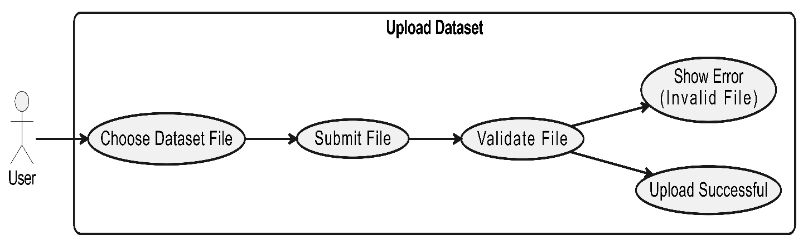
Figure 1 Use case Diagram Upload Dataset

Use case diagram Details
Use Case ID | UC_01
Use Case Name | Upload Dataset
Description | Allows the user to upload a dataset file for analysis.
Primary Actor | User
Secondary Actor | None
Pre-Condition | Dataset is uploaded and ready for analysis.
Post-Condition | What is the output of this function
Basic Flow | Actor Action | System Action
 | Chooses and submits a dataset file | Validates and stores the dataset file
Alternate Flow | If the file is invalid, system shows an error.
Table 8 Use case Upload Dataset

Preprocess Dataset:

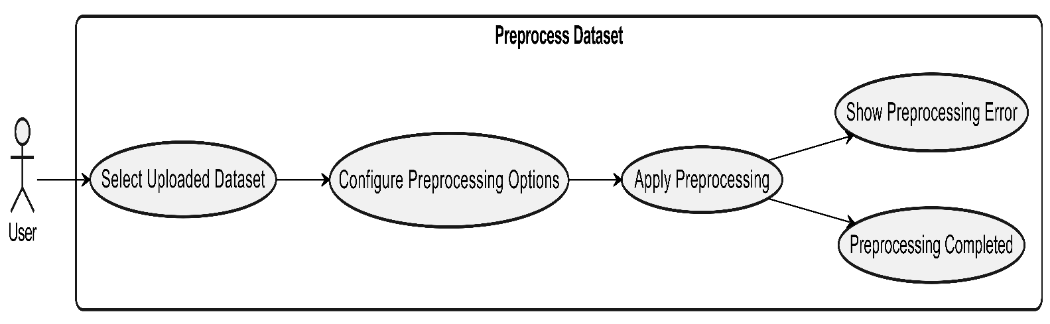
Figure 2 Use case Diagram Preprocess Dataset
Use case diagram Details
Use Case ID | UC_02
Use Case Name | Preprocess Dataset
Description | Allow the user to preprocess the uploaded dataset.
Primary Actor | User
Secondary Actor | None
Pre-Condition | Dataset must be uploaded successfully.
Post-Condition | Dataset is cleaned and prepared for model training.
Basic Flow | Actor Action | System Action
 | Selects dataset and applies preprocessing options | Cleans and preprocesses the dataset
Alternate Flow | If preprocessing fails, system shows an error.
Table 9 Use case Preprocess Dataset

Train Model:

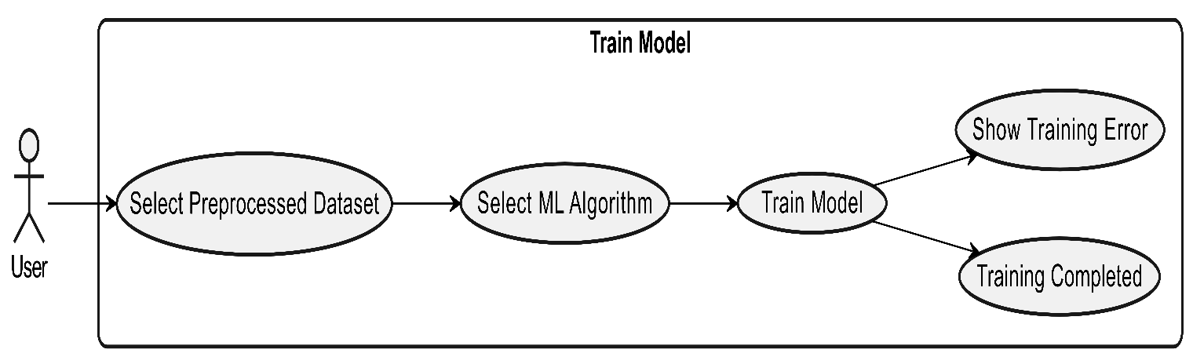
Figure 3 Use case Diagram Train Model

Use case diagram Details

Use Case ID | UC_03
Use Case Name | Train Model
Description | Allows the user to train a machine learning model.
Primary Actor | User
Secondary Actor | None
Pre-Condition | Dataset must be preprocessed successfully.
Post-Condition | Trained model is saved for traffic classification.
Basic Flow | Actor Action | System Action
 | Selects dataset and algorithm | Trains and stores the machine learning model
Alternate Flow | If training fails, system shows an error.
Table 10 Use case Train Model

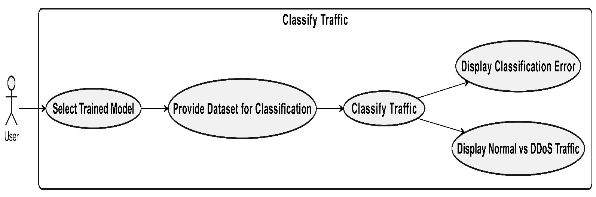
Classify Traffic:

Figure 4 Use case Diagram Classify Traffic

Use case diagram Details

Use Case ID | UC_04
Use Case Name | Classify Traffic
Description | Allows the user to classify traffic as normal or DDoS.
Primary Actor | User
Secondary Actor | None
Pre-Condition | A trained model must be available in the system.
Post-Condition | Traffic is classified as normal or DDoS and displayed.
Basic Flow | Actor Action | System Action
 | Selects model and dataset | Classifies traffic and shows normal vs DDoS traffic
Alternate Flow | If classification fails, system shows an error.
Table 11 Use case Classify Traffic

Visualize Results:

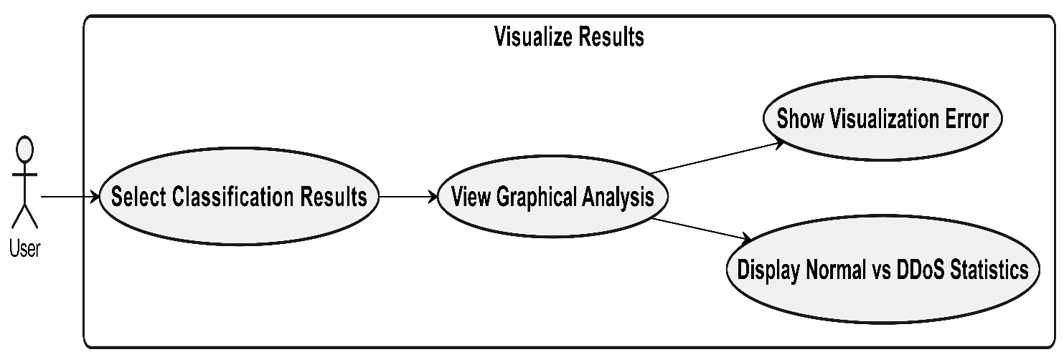
Figure 5 Use case Diagram Visualize Results

Use case diagram Details

Use Case ID | UC_05
Use Case Name | Visualize Results
Description | Allows the user to view visual analysis of classification results in graphical form.
Primary Actor | User
Secondary Actor | None
Pre-Condition | Traffic must be classified successfully.
Post-Condition | Graphical results are displayed to the user.
Basic Flow | Actor Action | System Action
 | Selects classification results | Displays graphs and normal vs DDoS statistics
Alternate Flow | If visualization fails, system shows an error.
Table 12 Use case Visualize Results

Generate Report:
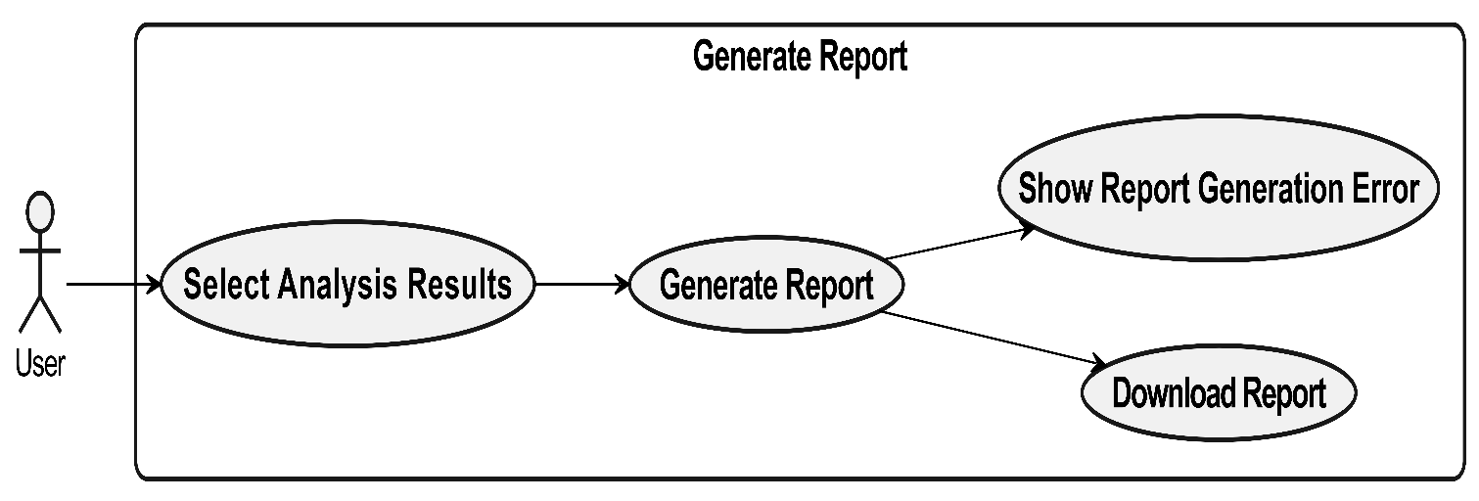

Figure 6 Use case Diagram Generate Report

Use case diagram Details

Use Case ID | UC_06
Use Case Name | Generate Report
Description | Allows the user to generate and download an analysis report of the results.
Primary Actor | User
Secondary Actor | None
Pre-Condition | Analysis results must be available in the system.
Post-Condition | Report is generated and downloaded by the user.
Basic Flow | Actor Action | System Action
 | Selects analysis results | Generates and allows download of the report
Alternate Flow | If report generation fails, system shows an error.
Table 13 Use case Generate Report

Chapter 4: Design

In this section, we provide the design analysis of our modules including the following designs
- Architecture Diagram
- ERD with data dictionary
- Data Flow diagram
- Class Diagram
- Activity Diagram
- Sequence Diagram
- Collaboration Diagram
- State Transition Diagram
- Component Diagram
- Deployment Diagram

Architecture Diagram
Define the graphical representation of the concepts, their principles, elements and components that are part of your project.
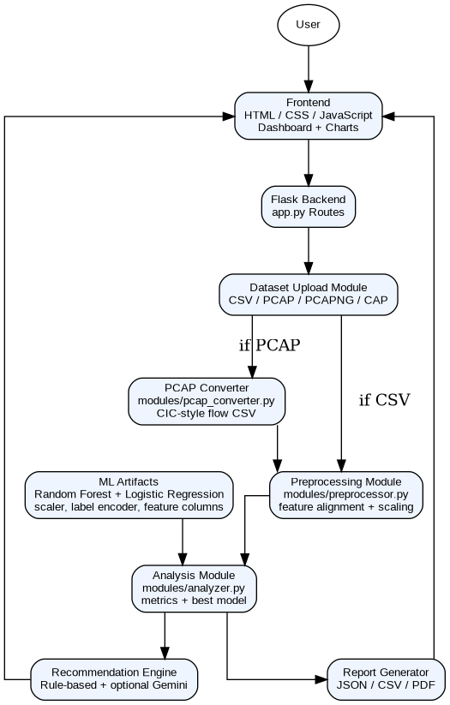

Figure 7 Architecture Diagram

ERD with data dictionary
Entity Relationship Diagram with complete relations with dependencies of your project

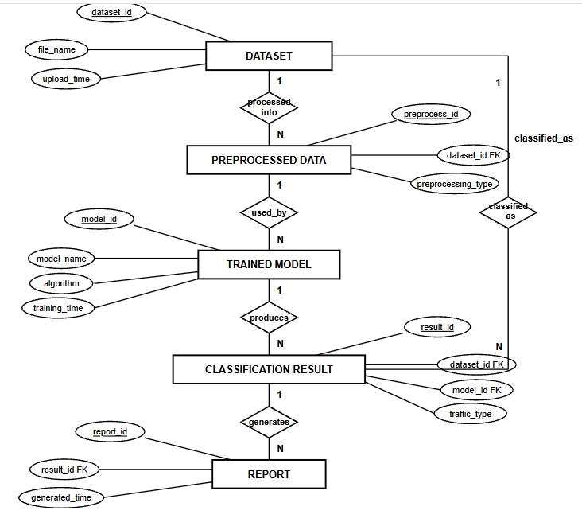
Figure 8 Entity Relationship Diagram
Data Dictionary of ERD
Entity | Attribute | Type | Description
Dataset | dataset_id | int (PK) | Unique dataset identifier
 | file_name | varchar | Name of uploaded dataset file
 | upload_time | datetime | Time of dataset upload
Preprocessed Data | preprocess_id | int (PK) | Unique preprocessing record ID
 | dataset_id | int (FK) | References Dataset
 | preprocessing_type | varchar | Applied preprocessing method
Trained Model | model_id | int (PK) | Unique trained model ID
 | model_name | varchar | Name of trained model
 | algorithm | varchar | Machine learning algorithm used
 | training_time | datetime | Time when model was trained
Classification Result | result_id | int (PK) | Unique classification result ID
 | model_id | int (FK) | References Trained Model
 | dataset_id | int (FK) | References Dataset
 | traffic_type | varchar | Normal or DDoS classification
Report | report_id | int (PK) | Unique report ID
 | result_id | int (FK) | References Classification Result
 | generated_time | datetime | Time of report generation
Table 14 Data Dictionary of ERD

Data Flow diagram
Data flow diagram includes two levels

The level 0
The flow of information inside the system is defined in this level

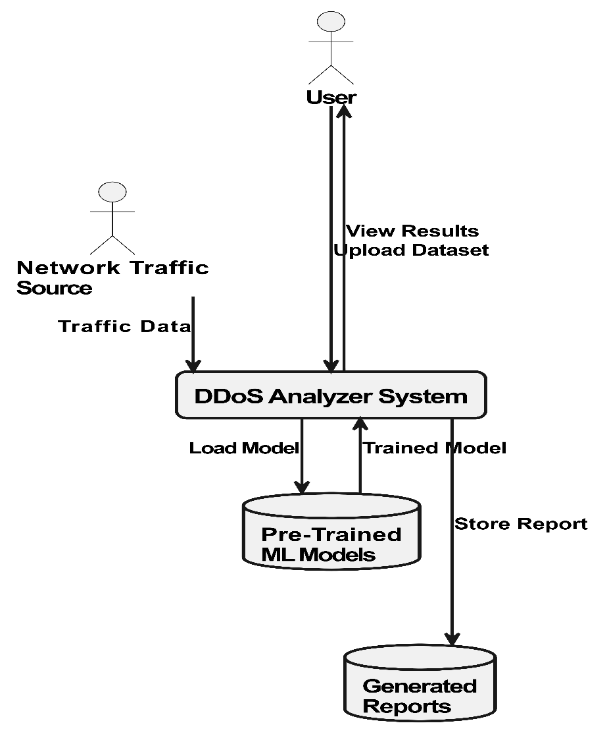

Figure 9 Level 0 DFD

The level 1
The flow of information outside the system is defined in this level

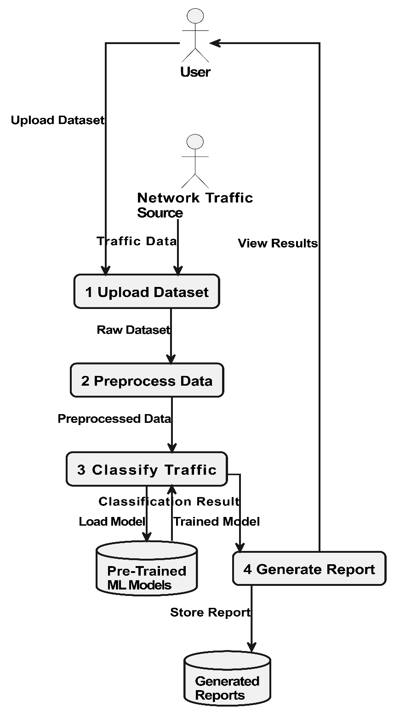

Figure 10 Level 1 DFD

Class Diagram
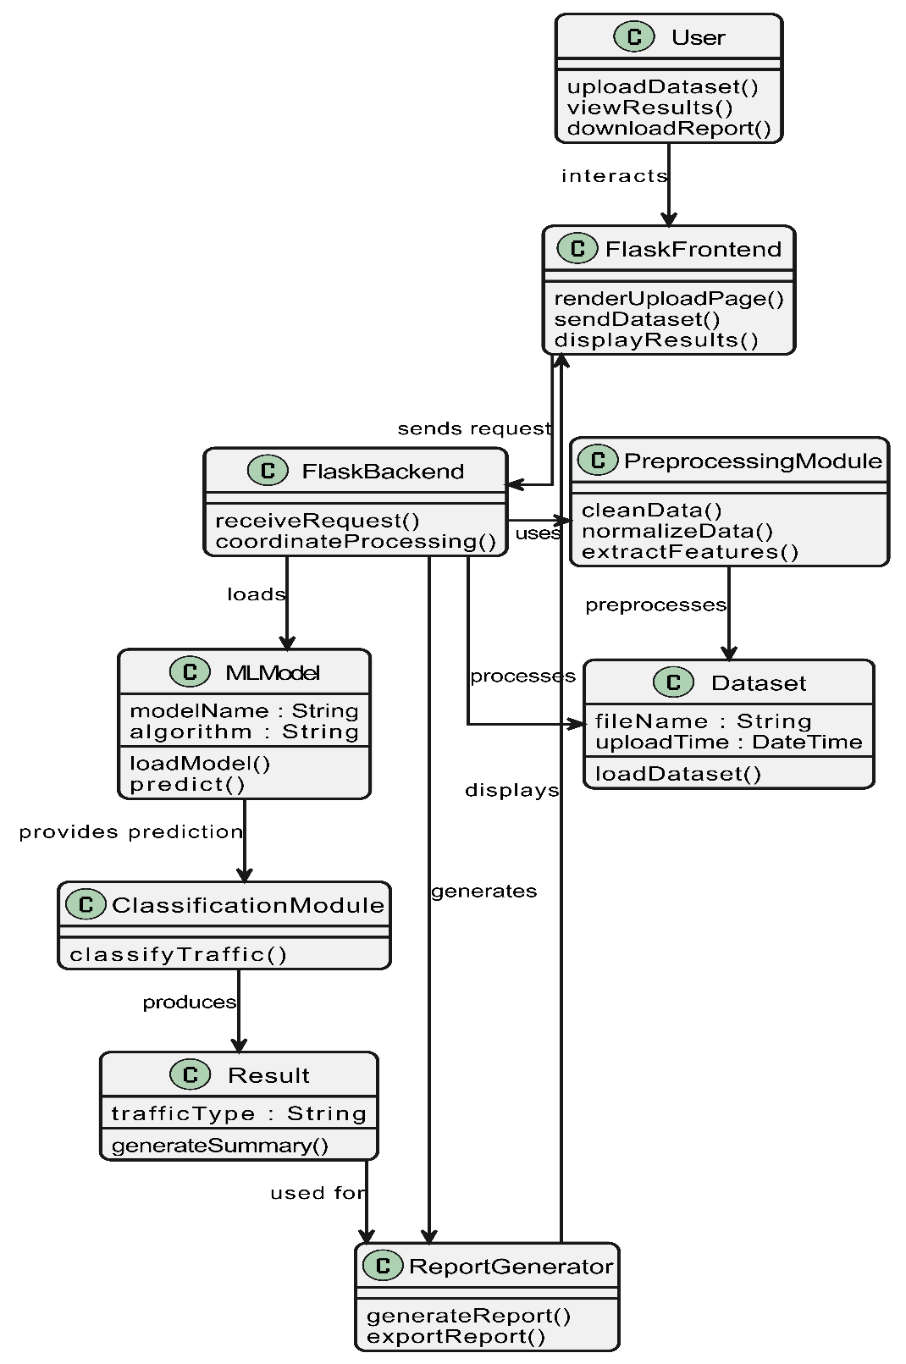
Describe the structure of a project by showing the systems classes, their attributes, operations (or methods), and the relationships among objects.

Figure 11 Class Diagram

Activity Diagram
This diagram includes all the activity diagrams of the functional requirements of your project along with the aggregated activity diagram
4.5.1 Activity diagram for Upload Dataset:

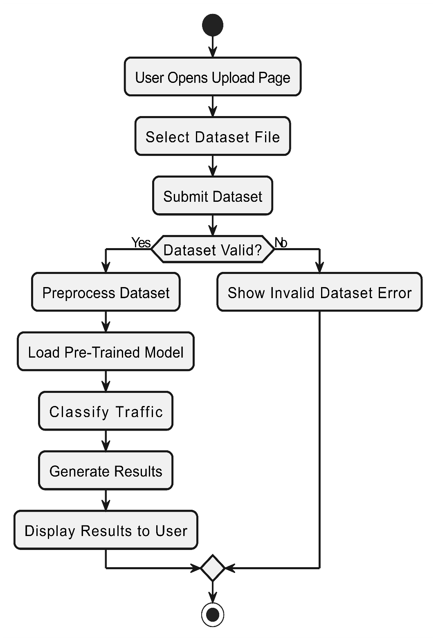

Figure 12 Activity Diagram Upload Dataset

4.5.2 Activity diagram for Preprocess Dataset:

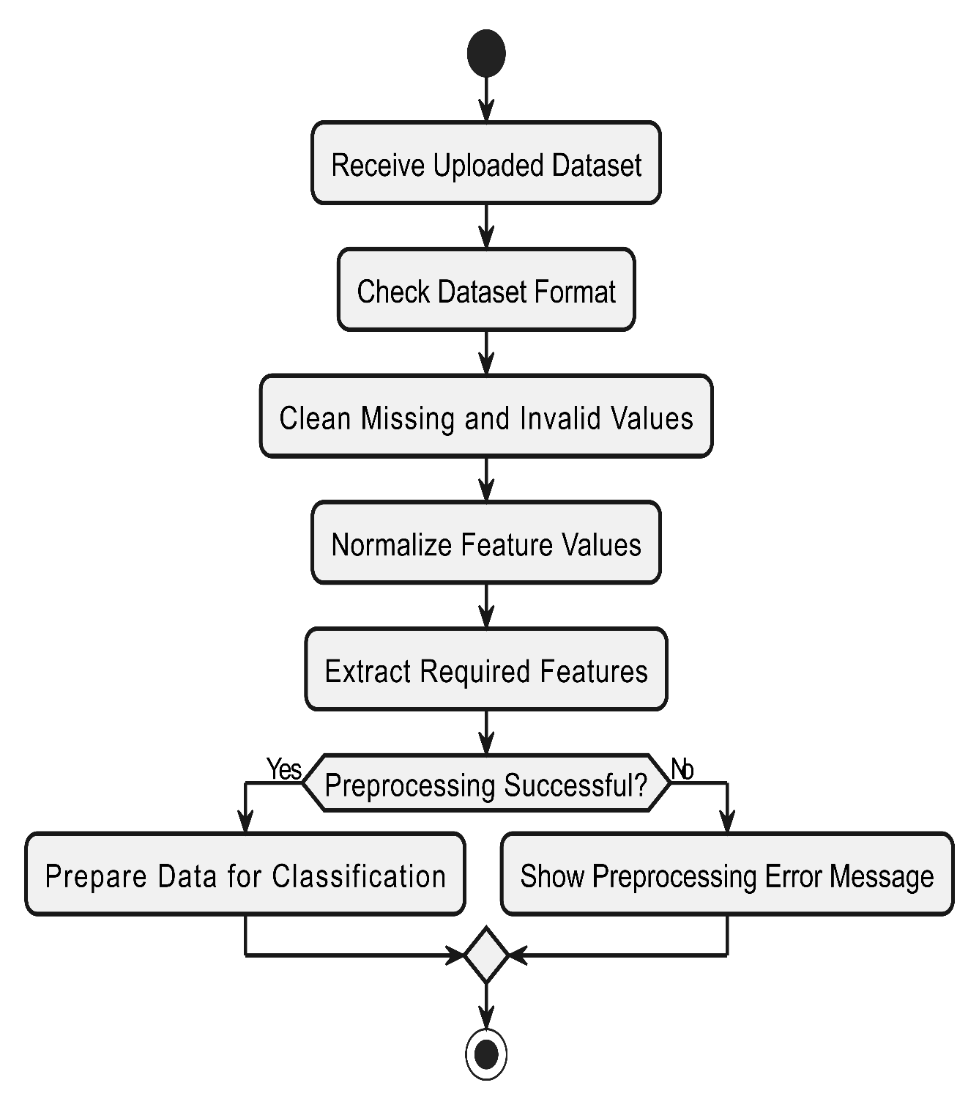
Figure 13 Activity Diagram Preprocess Dataset

4.5.3 Activity diagram for Classify Network Traffic:
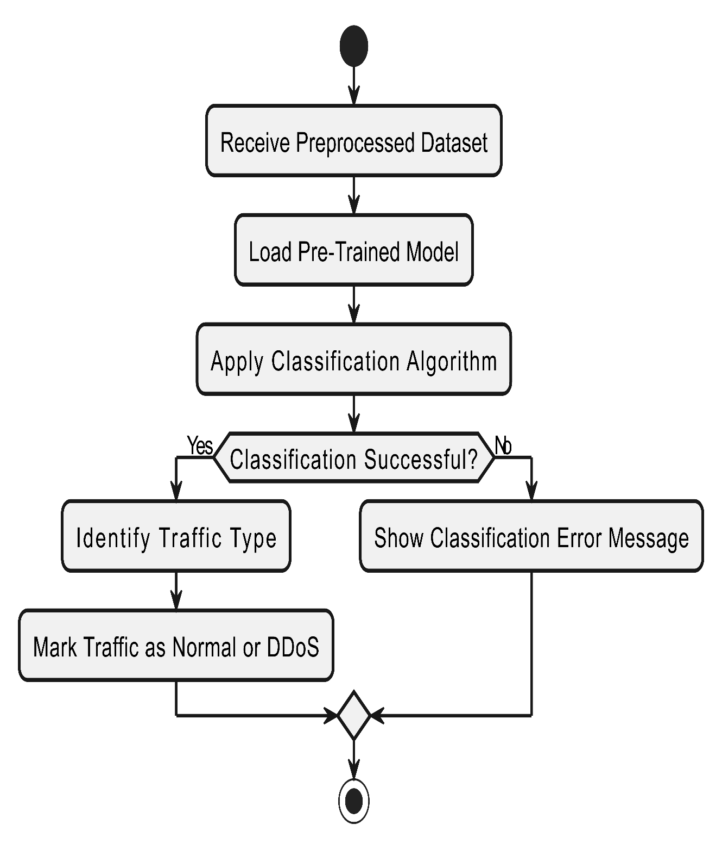

Figure 14 Activity Diagram Classify Network Traffic

4.5.4 Activity diagram for Generate Report:

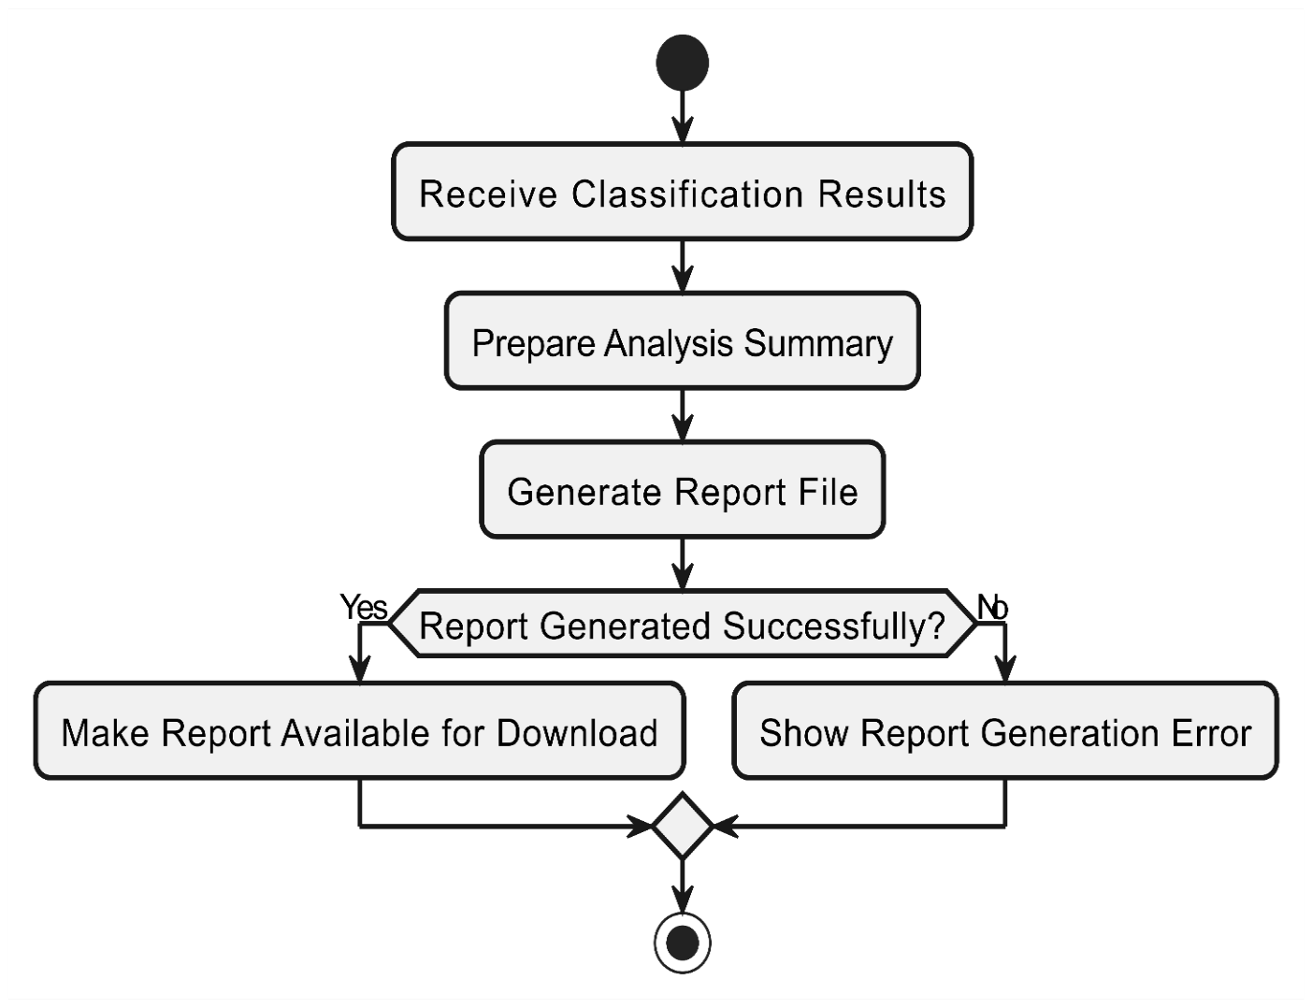

Figure 15 Activity Diagram Generate Report

4.5.5 Activity diagram for View Results and Download Report:

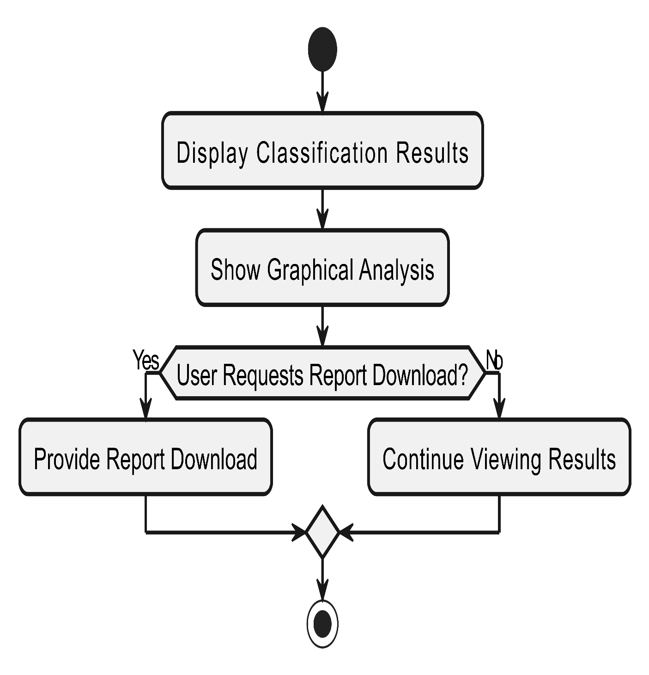

Figure 16 Activity Diagram View Results and Download Report

4.5.6 Activity diagram for Aggregated DDoS Analyzer System:

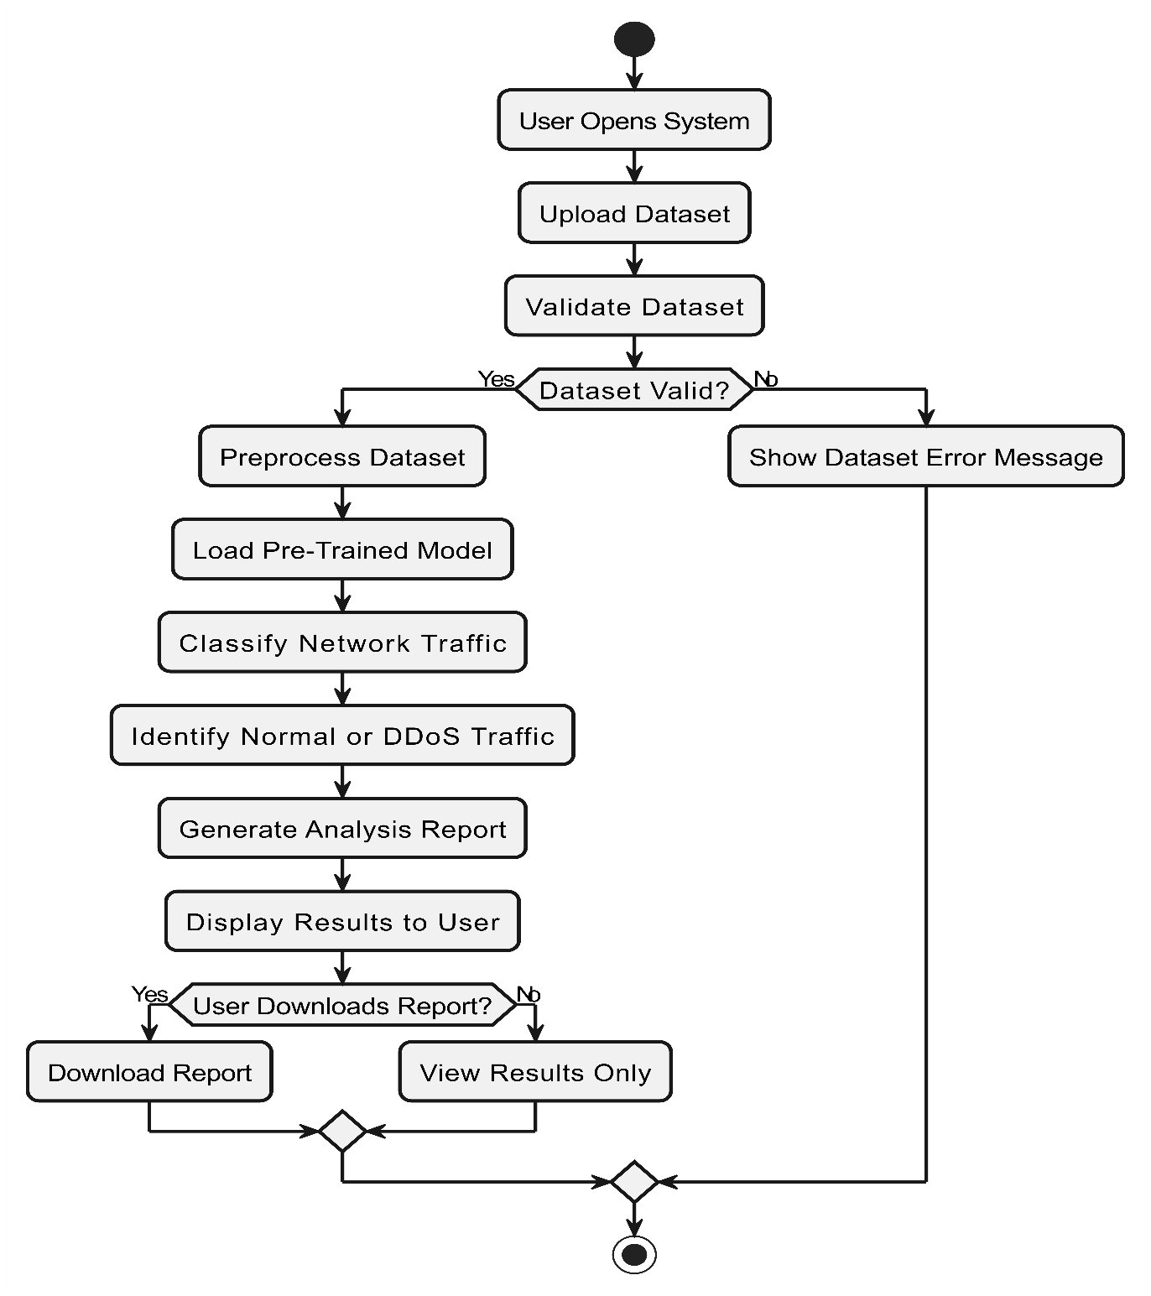

Figure 17 Activity Diagram Aggregated DDoS Analyzer System

Sequence Diagram
This diagram includes all the Sequence diagrams of the functional requirements of your project along with the aggregated Sequence diagram
4.6.1 Sequence diagram for Upload Dataset:
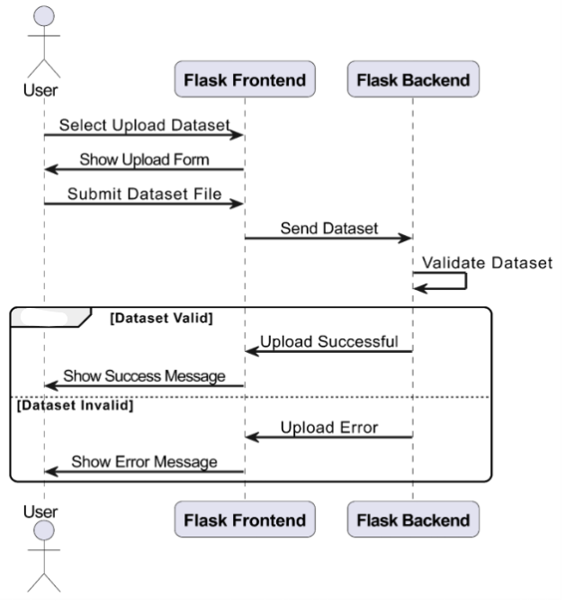

Figure 18 Sequence Diagram Upload Dataset

4.6.2 Sequence diagram for Preprocess Dataset:
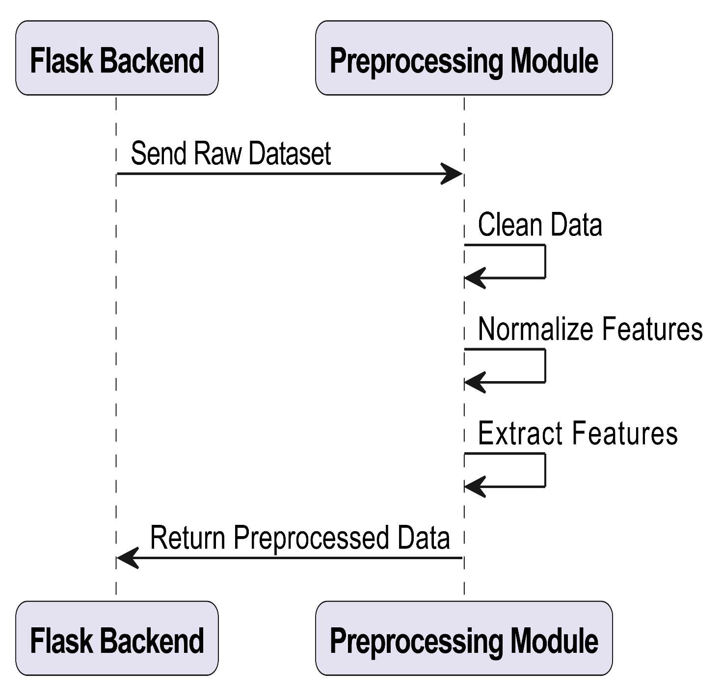

Figure 19 Sequence Diagram Create Account

4.6.3 Sequence diagram for Classify Network Traffic:
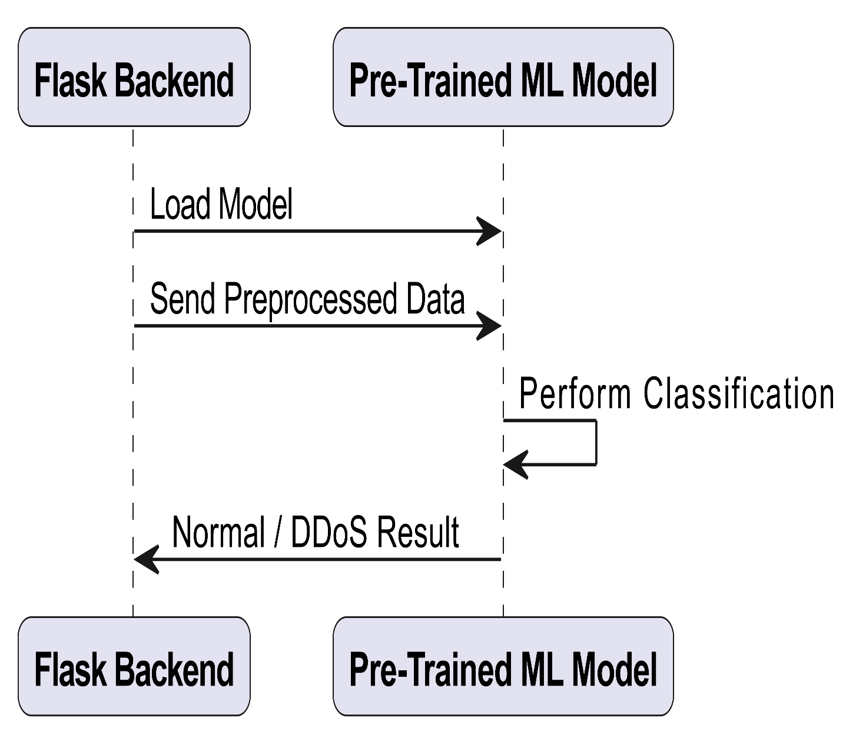

Figure 20 Sequence Diagram Classify Network Traffic

4.6.4 Sequence diagram for Generate Report:

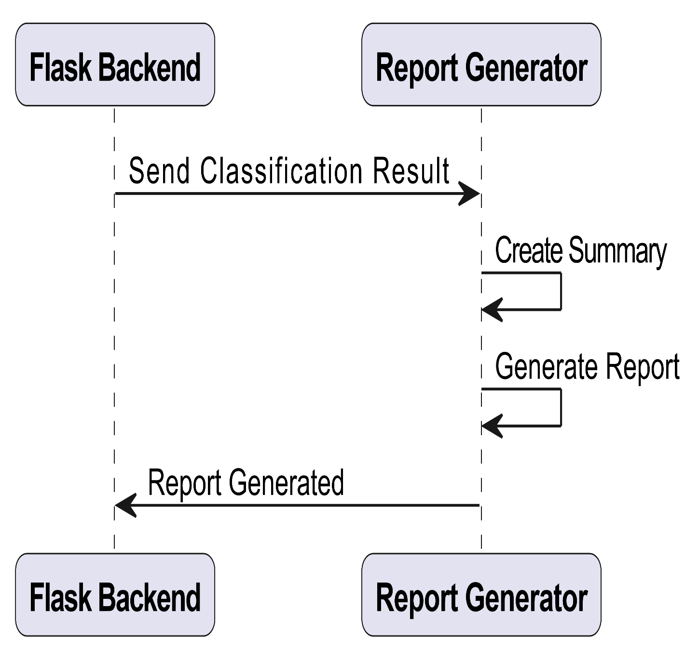

Figure 21 Sequence Diagram Generate Report

4.6.5 Sequence diagram for View Results & Download Report:

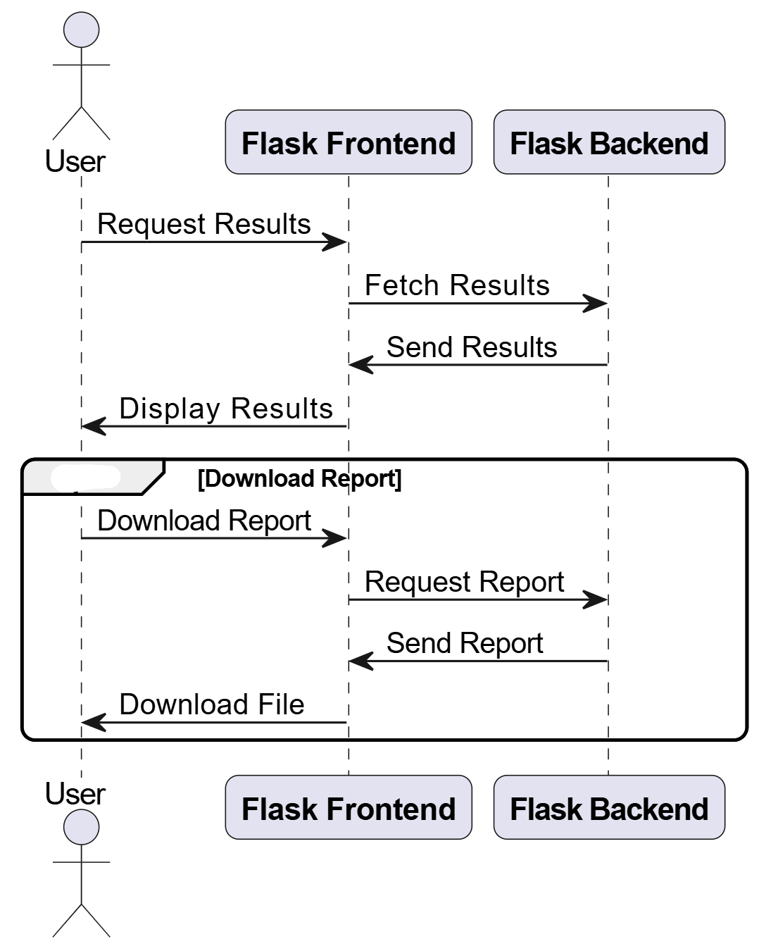
Figure 22 Sequence Diagram View Results & Download Report

4.6.6 Aggregated Sequence Diagram for DDoS Analyzer System:
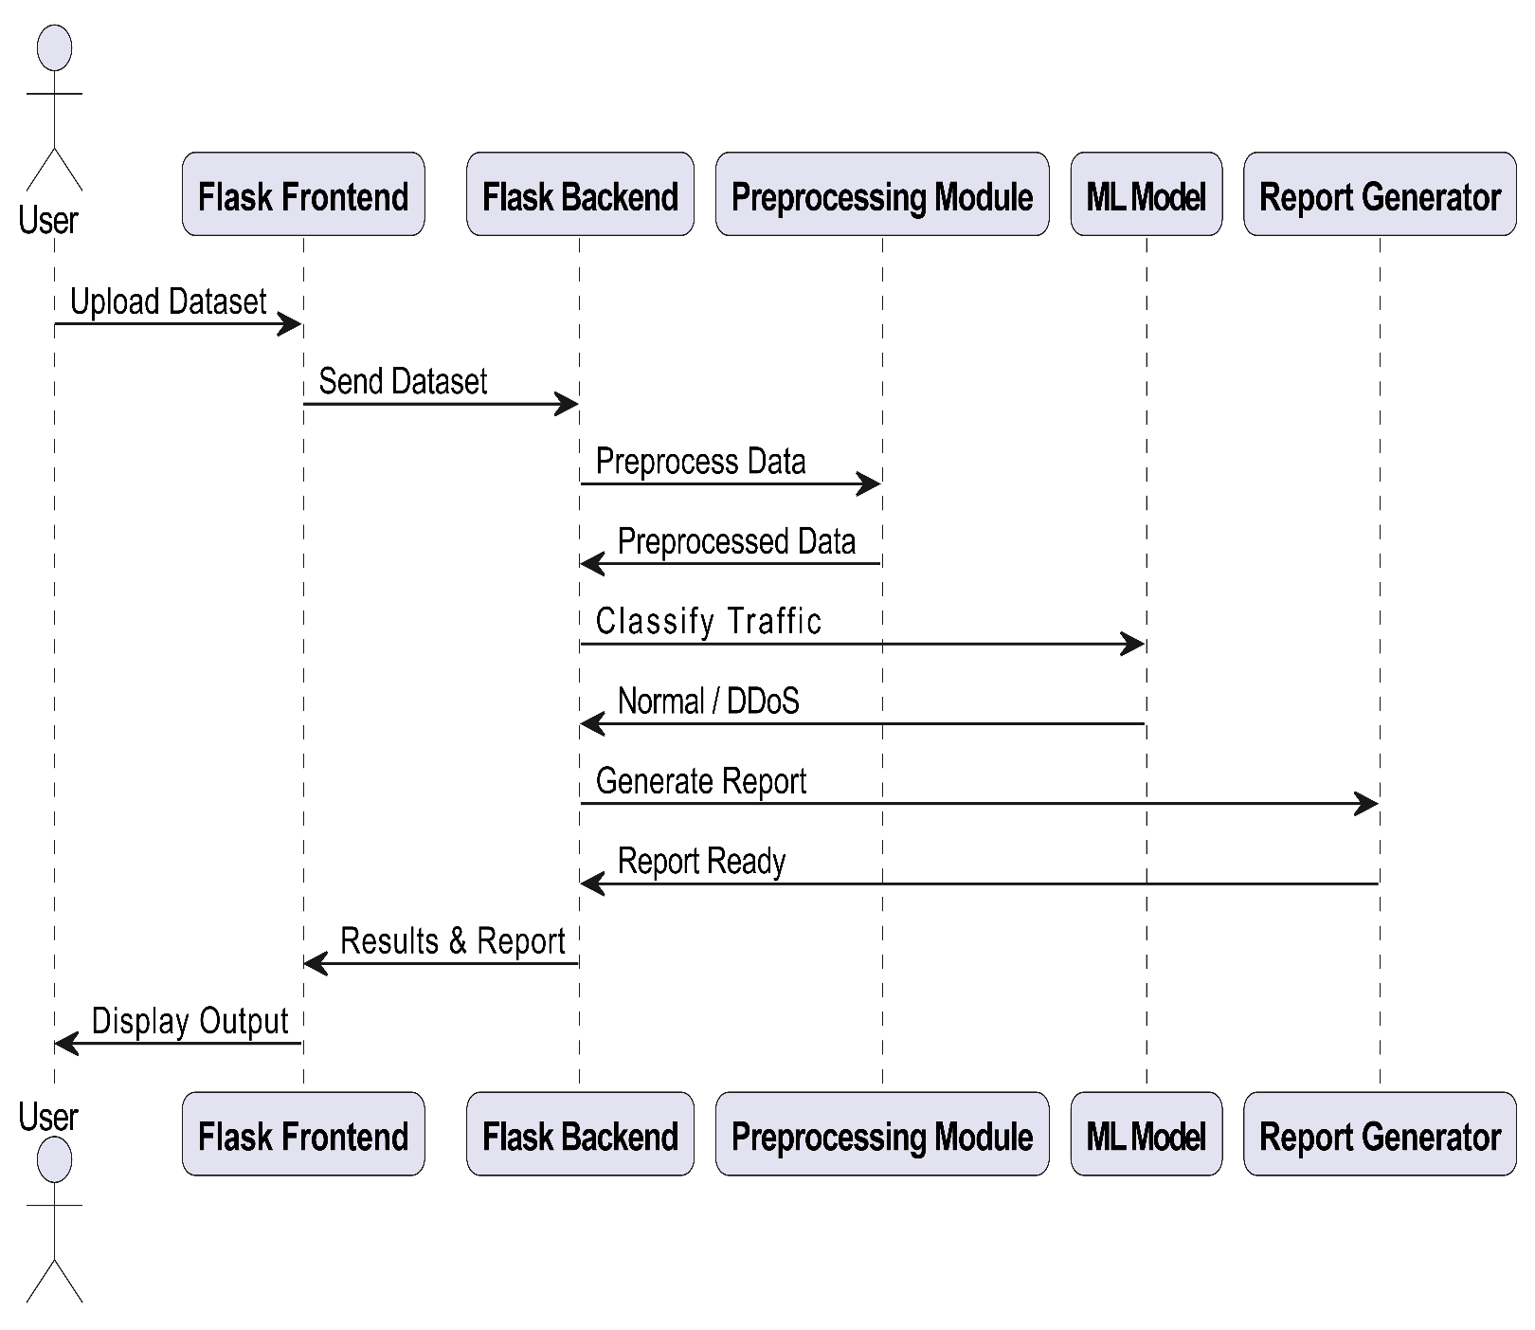

Figure 23 Sequence Diagram DDoS Analyzer System

Collaboration Diagram
It shows the object organization as shown below. Here in collaboration diagram the method call sequence is indicated by some numbering technique as shown below. The number indicates how the methods are called one after another. We have taken the same order management system to describe the collaboration diagram.

4.7.1 Collaboration Diagram – Upload Dataset
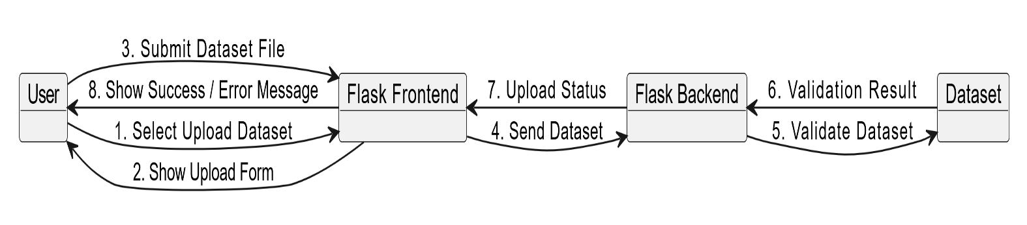

Figure 24 Collaboration Diagram Upload Dataset

4.7.2 Collaboration Diagram – Preprocess Dataset

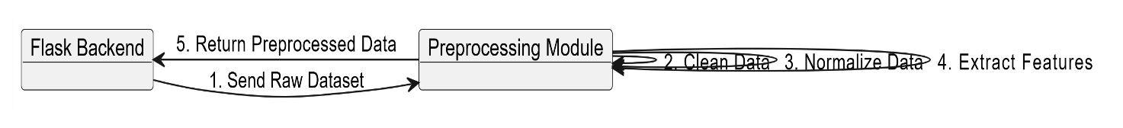

Figure 25 Collaboration Diagram Preprocess Dataset

4.7.3 Collaboration Diagram – Classify Network Traffic
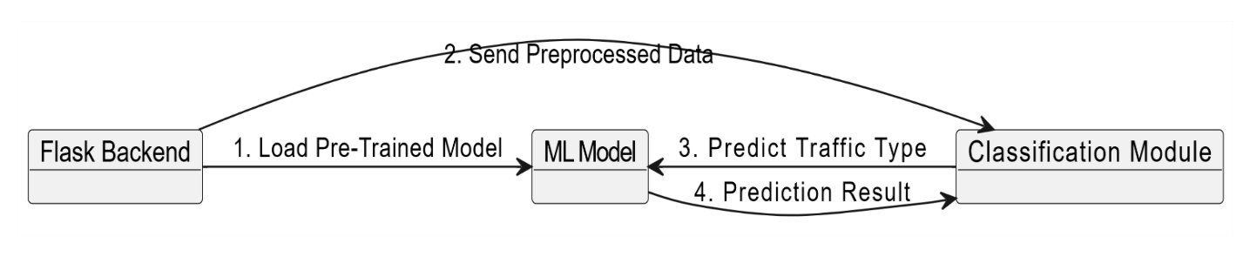

Figure 26 Collaboration Diagram Classify Network Traffic

4.7.4 Collaboration Diagram – Generate Report

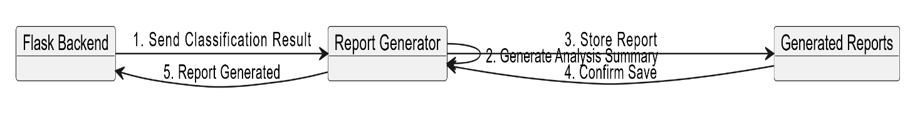

Figure 27 Collaboration Diagram Generate Report

4.7.5 Collaboration Diagram – View Results

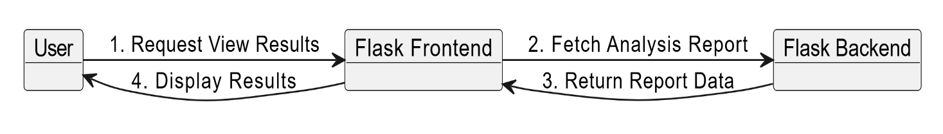

Figure 28 Collaboration Diagram View Results

State Transition Diagram
State Transition diagram is used to describe the states of different objects in its life cycle. So, the emphasis is given on the state changes upon some internal or external events. These states of objects are important to analyze and implement them accurately

State Transition Diagram – DDoS Analyzer System:
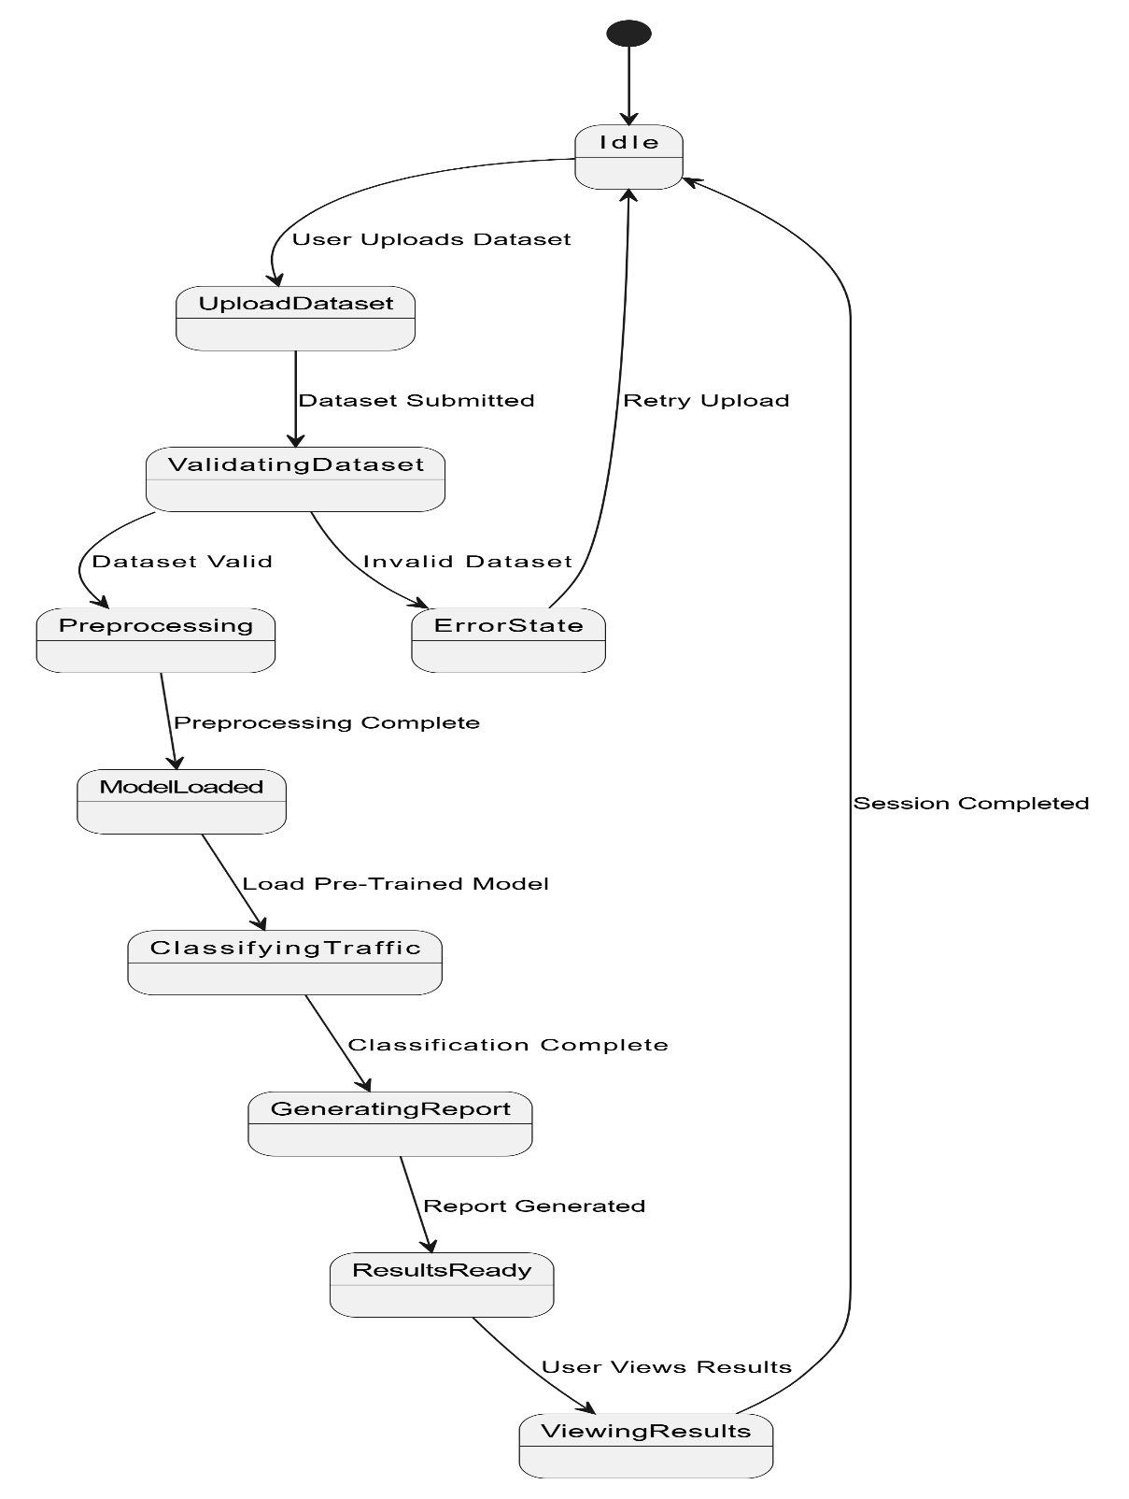

Figure 29 State Transition Diagram DDoS Analyzer System

Component Diagram
Component diagrams are used to describe the physical artifacts of a system. This artifact includes files, executables, libraries etc.
Component Diagram – DDoS Analyzer System:

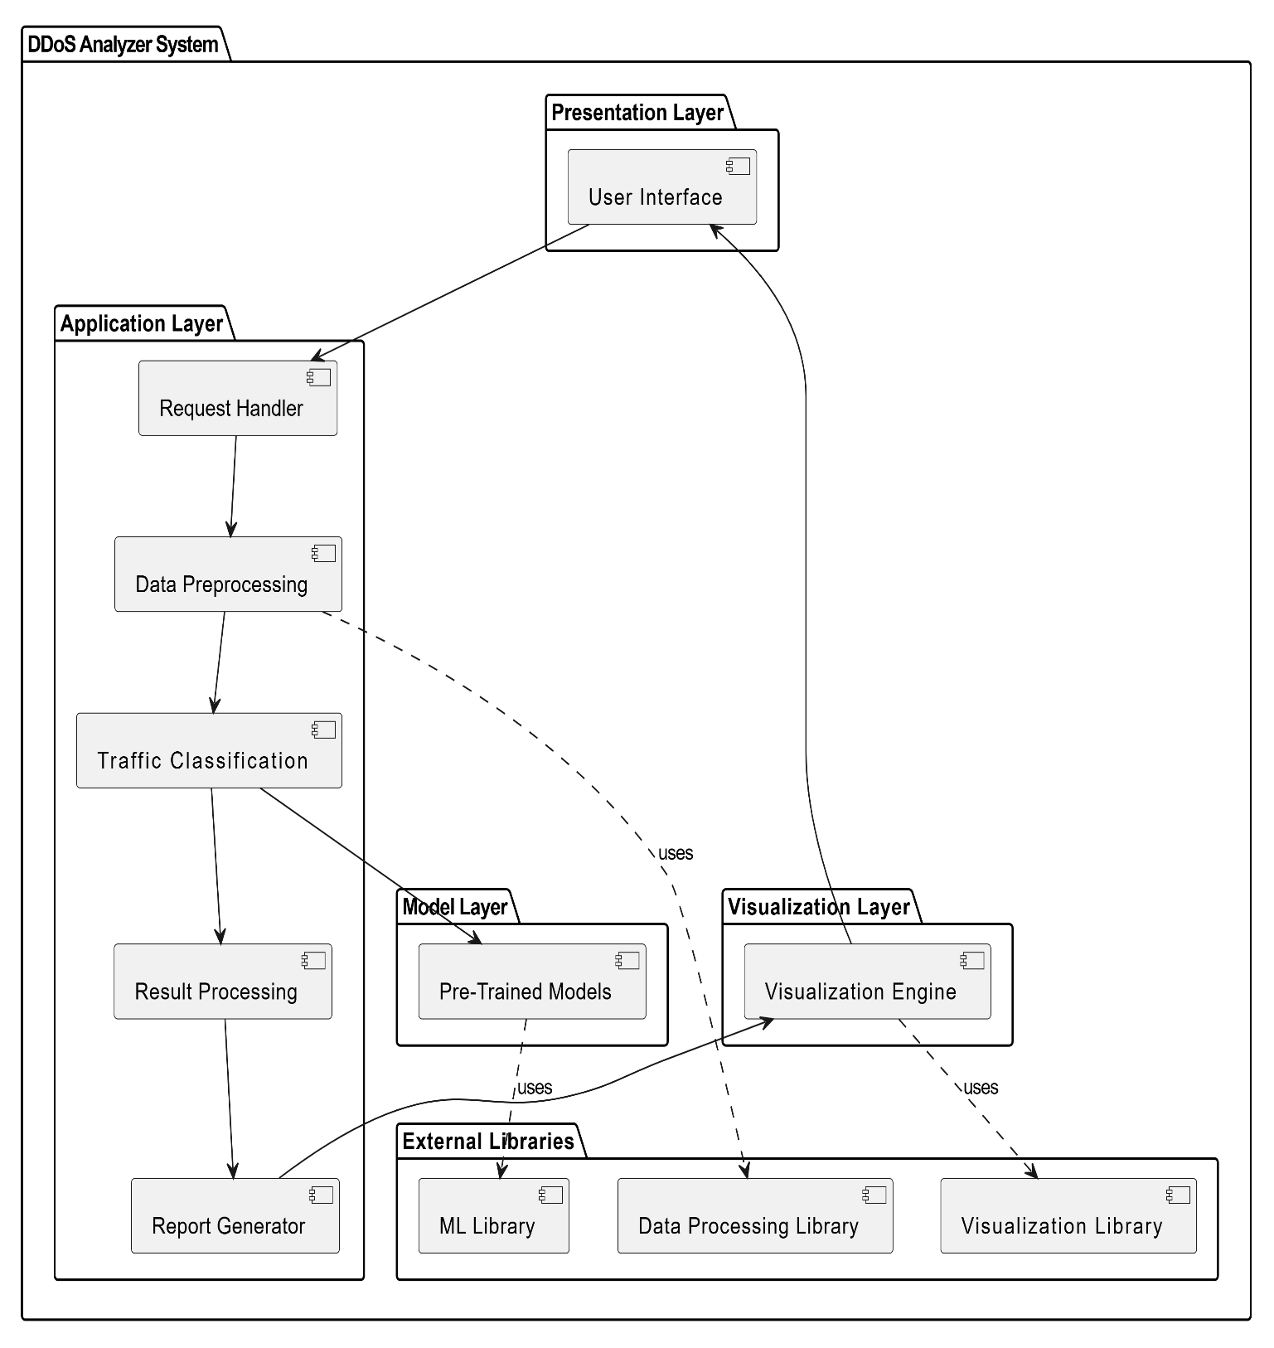
Figure 30 Component Diagram DDoS Analyzer System

Deployment Diagram
Deployment diagram represents the deployment view of a system. It is related to the component diagram.

Deployment Diagram – DDoS Analyzer System

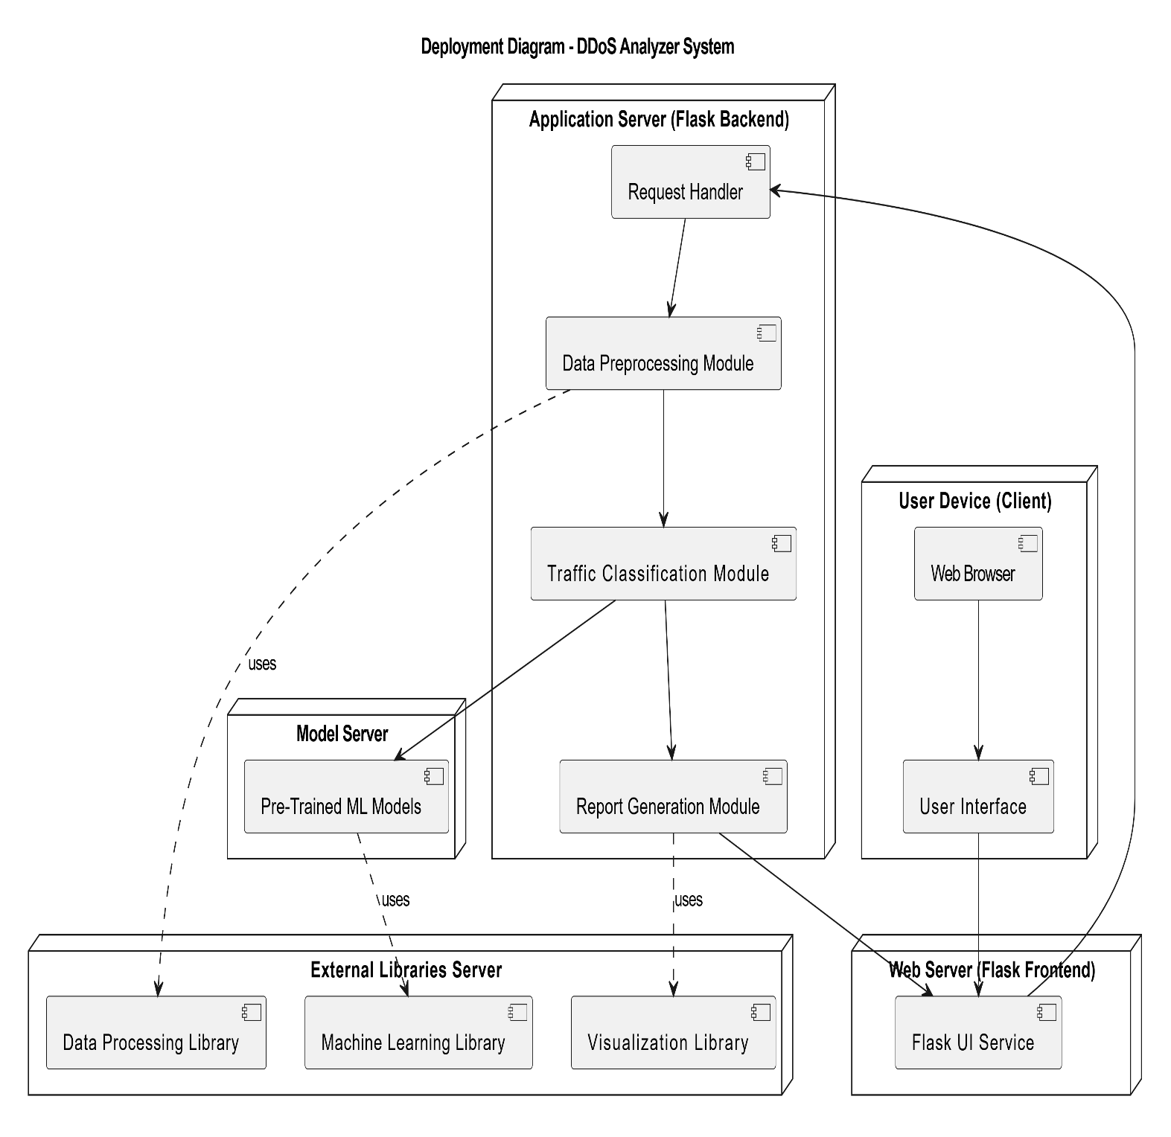
Figure 31 Deployment Diagram DDoS Analyzer System

Chapter 5: Testing

5.1 Test Case Specifications
Testing was planned around the implemented modules of DDoS Analyzer. Both positive and negative test cases were written to verify file upload, PCAP conversion, preprocessing, analysis, recommendations, export, and settings behavior.
Test Cases for DDoS Analyzer :
 | Positive Test Case
ID | TC_UPLOAD_CSV_SUCCESS
Priority | High
Description | Verify CSV upload and analysis pipeline.
Reference | FR_01
Users | User
Pre-requisites | A | App running.
 | B | Valid CIC-style CSV available.
Steps | A | Open dashboard in browser.
 | B | Choose a CSV dataset file.
 | C | Click Analyze.
Input | CSV dataset file
Expected result | Dataset analyzed and dashboard displays traffic results.
Status | Tested, Passed
Table 15 Positive Test Case – CSV Upload
 | Negative Test Case
ID | TC_UPLOAD_INVALID_FILE
Priority | High
Description | Verify unsupported file format rejection.
Reference | FR_01
Users | User
Pre-requisites | A | App running.
Steps | A | Open dashboard.
 | B | Upload a .txt or unsupported file.
 | C | Click Analyze.
Input | Unsupported file (e.g. .txt)
Expected result | System displays supported format error message.
Status | Tested, Passed
Table 16 Negative Test Case – Invalid File Upload
 | Positive Test Case
ID | TC_PCAP_CONVERT_SUCCESS
Priority | High
Description | Verify PCAP upload and conversion to flow CSV.
Reference | FR_02
Users | User
Pre-requisites | A | Valid TCP/UDP PCAP file available.
 | B | App running.
Steps | A | Open dashboard.
 | B | Upload PCAP file.
 | C | Click Analyze.
Input | PCAP file with TCP/UDP flows
Expected result | PCAP converted to CSV and analyzed successfully.
Status | Tested, Passed
Table 17 Positive Test Case – PCAP Conversion

 | Negative Test Case
ID | TC_PCAP_EMPTY_FAILURE
Priority | Medium
Description | Verify empty PCAP handling.
Reference | FR_02
Users | User
Pre-requisites | A | Empty PCAP file available.
 | B | App running.
Steps | A | Open dashboard.
 | B | Upload empty PCAP file.
 | C | Click Analyze.
Input | Empty PCAP file
Expected result | System shows PCAP conversion failed error.
Status | Tested, Passed
Table 18 Negative Test Case – Empty PCAP

 | Negative Test Case
ID | TC_PREPROCESS_NO_FEATURES
Priority | High
Description | Reject dataset with no recognizable CICFlowMeter features.
Reference | FR_03
Users | User
Pre-requisites | A | CSV with unrelated column names.
 | B | App running.
Steps | A | Open dashboard.
 | B | Upload the invalid CSV.
 | C | Click Analyze.
Input | CSV with unrelated columns
Expected result | System shows no recognizable feature columns error.
Status | Tested, Passed
Table 19 Negative Test Case – No Recognizable Features

 | Positive Test Case
ID | TC_EXPORT_PDF
Priority | Medium
Description | Verify PDF report export after analysis.
Reference | FR_07
Users | User
Pre-requisites | A | Analysis already completed.
 | B | App running.
Steps | A | Complete an analysis run.
 | B | Click Generate PDF.
 | C | Save downloaded file.
Input | Last analysis result
Expected result | ddos_analysis_report.pdf downloads successfully.
Status | Tested, Passed
Table 20 Positive Test Case – PDF Export

5.2 Black Box Test Cases
Black box testing was performed from the user perspective without inspecting internal code. The focus was on inputs, outputs, and visible system behavior for each module.

5.2.1 Equivalence Partitions (EP)
Equivalence class partitioning reduces the number of test cases by grouping inputs that produce similar system behavior. The table below shows valid and invalid classes for the DDoS Analyzer.
Module | Variable | Valid Classes | Invalid Classes
Upload | File type | csv, pcap, pcapng, cap | txt, exe, jpg, empty filename
Upload | File size | 0 MB to 500 MB | Greater than 500 MB
PCAP Conversion | Packet content | TCP/UDP IP flows | Empty capture, unsupported protocol
Preprocessing | Feature columns | CICFlowMeter-style trained columns | Unrelated columns only
Label Handling | Label column | BENIGN, DDoS, absent label | Unknown label values
Settings | Gemini key | Non-empty key or environment key | Empty key when AI is required
Export | Analysis state | Analysis already completed | No last result available
Table 21 Equivalence Partitioning

5.2.2 Boundary Value Analysis
Boundary value analysis tests input values at and near the edges of valid and invalid ranges.
Boundary Item | Input Value | Expected Result
Upload file size | 0 KB file | Rejected or preprocessing failure with error.
Upload file size | File near 500 MB | Accepted if memory permits.
Upload file size | File greater than 500 MB | Rejected by Flask max content length.
Feature availability | 0 recognizable trained features | Rejected with error message.
Feature availability | 1 or more recognizable features | Accepted; missing features filled with 0.
DDoS percentage | 0% to 20% | Low threat recommendation shown.
DDoS percentage | Greater than 20% up to 50% | Elevated traffic recommendation shown.
DDoS percentage | Greater than 50% | Critical DDoS activity recommendation shown.
Table 22 Boundary Value Analysis

5.2.3 Decision Table Testing

Decision table testing verifies that the system behaves correctly for every meaningful combination of input conditions.
Condition / Action | Case 1 | Case 2 | Case 3 | Case 4 | Case 5
File uploaded | Yes | Yes | Yes | Yes | No
Extension allowed | Yes | No | Yes | Yes | -
PCAP file | No | - | Yes | No | -
Conversion successful | - | - | Yes | - | -
Recognizable features | Yes | - | Yes | No | -
Run analysis | Yes | No | Yes | No | No
Show error | No | Yes | No | Yes | Yes
Table 23 Decision Table Testing

5.2.4 State Transition Testing

State transition testing verifies that the system moves correctly between states based on valid and invalid events.
Current State | Event | Next State
Idle | User uploads valid CSV | Dataset Loaded
Idle | User uploads PCAP | Converting PCAP
Converting PCAP | Conversion successful | Dataset Loaded
Dataset Loaded | Preprocessing starts | Preprocessing
Preprocessing | Features scaled | Analyzing
Analyzing | Prediction completed | Results Ready
Results Ready | User exports report | Report Downloaded
Any processing state | Error occurs | Error State
Table 24 State Transition Testing

5.2.5 Use Case Testing

Use case testing verifies the system on each transaction from start to finish based on the defined use cases.
UC ID | Use Case Name | Main Flow | Expected Result | Status
UC_01 | Upload Dataset | User uploads supported file. | File accepted and passed to analysis pipeline. | Passed
UC_02 | Convert PCAP | PCAP is parsed into flows. | Flow CSV generated. | Passed
UC_03 | Analyze Traffic | System preprocesses and predicts. | BENIGN/DDoS counts and model metrics shown. | Passed
UC_04 | View Results | User views dashboard after analysis. | Charts, cards, and model comparison shown. | Passed
UC_05 | Generate Recommendations | System evaluates DDoS percentage. | Recommendations displayed. | Passed
UC_06 | Export Report | User requests JSON/PDF/CSV export. | Download begins. | Passed
UC_07 | Configure Settings | User saves Gemini key. | Config updated. | Passed
Table 25 Use Case Testing

5.3 White Box Test Cases

White box testing examined the internal control flow of Python modules. Cyclomatic complexity values are estimated from visible decision points in the implemented functions.

5.3.1 Cyclometric Complexity

Cyclomatic complexity measures the number of linearly-independent paths through a program module. Lower complexity means easier testing and lower risk during modification.
Module / Function | Decision Points | Cyclomatic Complexity | Complexity Level
app.allowed_file() | 1 | 2 | Low
app.analyze() | 8 | 9 | High
preprocessor.preprocess_uploaded() | 5 | 6 | Medium
analyzer.run_analysis() | 9 | 10 | High
analyzer.build_recommendations() | 4 | 5 | Medium
pcap_converter.convert_pcap_to_csv() | 5 | 6 | Medium
pcap_converter._process_pcap() | 12 | 13 | High
llm.generate_llm_recommendations() | 3 | 4 | Low
report.generate_pdf() | 4 | 5 | Medium
Table 26 Cyclomatic Complexity Analysis

5.4 Performance Testing
Performance testing evaluates system responsiveness and stability under expected workloads. The table below shows observed behavior for each performance parameter.
Parameter | Observation / Expected Behavior | Result
Upload handling | Supports up to 500 MB by configuration. | Passed
CSV preprocessing | Handles duplicate removal, NaN filling, feature alignment, and scaling. | Passed
Model prediction | Random Forest and Logistic Regression predictions generated from scaled matrix. | Passed
PCAP conversion | Parses TCP/UDP flows and writes CSV; larger PCAPs take longer. | Passed
Export generation | JSON and PDF exports generated after analysis. | Passed
Memory use | Depends on dataset size; moderate datasets work on 8 GB RAM. | Acceptable
Table 27 Performance Testing

5.5 Stress Testing
Stress testing verifies system stability when subjected to overload or unusual input conditions. Recovery from each stress scenario was also observed.
Stress Scenario | System Behavior | Result
Upload unsupported file repeatedly | System consistently rejects file type. | Passed
Upload PCAP with no TCP/UDP flows | Conversion error shown without crashing. | Passed
Analyze CSV with missing trained features | Missing features filled with 0 where possible. | Passed
Analyze CSV with no recognizable features | Clear error returned to user. | Passed
Gemini API unavailable | Static recommendation fallback used. | Passed
Export before any analysis | Export route returns not found response. | Passed

Table 28 Stress Testing

5.6 System Testing
System testing evaluates the complete end-to-end workflow of DDoS Analyzer from dataset upload through report export, verifying that all integrated modules work together correctly.
Step | Description | Status
1 | Open dashboard in browser. | Passed
2 | Upload supported dataset (CSV or PCAP). | Passed
3 | Convert PCAP to CSV if PCAP was uploaded. | Passed
4 | Preprocess and scale feature columns. | Passed
5 | Run Random Forest and Logistic Regression models. | Passed
6 | Display traffic summary cards and model comparison. | Passed
7 | Generate rule-based or Gemini recommendations. | Passed
8 | Export JSON, PDF, or CSV summary report. | Passed
Table 29 System Testing Coverage

5.7 Regression Testing

Regression testing was applied after updates such as adding PCAP conversion, updating recommendations, adding export functions, and improving settings behavior. Tests verified that existing features remained unaffected by each change.

5.7.1 Selecting Regression Tests

- File upload and validation tests were selected because every workflow begins with uploading a dataset.

- Preprocessing tests were selected because trained model accuracy depends on correct feature order and scaling

- Analysis tests were selected because the model comparison and best model output are core project features.
- Export tests were selected because reports are part of the user deliverables.

- Recommendation tests were selected because the system must work even when the Gemini service is unavailable.

5.7.2 Regression Testing Steps
- Select tests affected by recent code changes.
- Run upload, conversion, preprocessing, analysis, recommendation, and export tests.
- Compare new results with expected system behavior.
- Fix defects if any route or module breaks.
- Repeat tests before preparing the final build.

Module | Regression Test Performed | Result
Upload Module | CSV and PCAP upload after converter changes. | Passed
Preprocessor | Feature alignment after model artifact updates. | Passed
Analyzer | Model metrics after metadata update. | Passed
Recommendations | Static fallback after Gemini integration. | Passed
Report Generator | PDF output after result structure updates. | Passed
Settings | Save and clear API key flow. | Passed
Table 30 Regression Testing Coverage

Chapter 6: Tools and Techniques
This chapter lists the programming languages, development tools, libraries, frameworks, and supporting utilities used in the implemented DDoS Analyzer project.

Category | Tools / Technologies | Purpose
Programming Languages | Python, HTML, CSS, JavaScript | Backend, frontend, data processing, and dashboard interaction.
Backend Framework | Flask | Routes for analysis, export, settings, and static content.
Machine Learning | Scikit-learn, Joblib | Training artifact loading, Random Forest, Logistic Regression, scaler, and label encoder.
Data Processing | Pandas, NumPy | CSV loading, feature cleaning, numeric operations, and preprocessing.
Packet Processing | Scapy | Reading PCAP files and extracting TCP/UDP flow information.
Reporting | ReportLab | Generating PDF reports from analysis results.
AI Recommendations | Google Gemini API (optional) | Context-aware security recommendations when configured.
Development Tools | Visual Studio Code, Git, Browser Developer Tools | Coding, version control, and testing.
Lab Tools | Kali Linux, Windows VM, Wireshark, CICFlowMeter | Controlled dataset creation and traffic capture verification.
Deployment / Execution | Local Flask server | Prototype execution using python app.py.
Table 31 Tools and Techniques

  - Python is used for the backend, machine learning, preprocessing, PCAP conversion, and report generation.

  - Flask handles all web routes including analysis, export, settings, and static content delivery.

  - HTML, CSS, and JavaScript power the user interface and dashboard interactions.
  - Scikit-learn and Joblib load trained Random Forest and Logistic Regression model artifacts.

  - Pandas and NumPy manage CSV loading, feature alignment, and preprocessing operations.
  - Scapy reads PCAP files and extracts TCP/UDP flow information for conversion.
  - ReportLab generates PDF reports from analysis results.
  - Visual Studio Code and Git were used for development and version control.
  - Kali Linux and Windows VMs were used in a controlled lab for DDoS dataset generation.

Chapter 7: Summary and Conclusion

7.1 Summary
DDoS Analyzer was developed to bridge a critical gap in existing network security tools — most available solutions focus on real-time traffic monitoring and lack the ability to perform batch-based analysis on historical or pre-captured network traffic. No accessible, open-source tool existed that could take an uploaded dataset, classify it using machine learning, and deliver actionable insights without requiring live packet capture or specialized infrastructure. This project directly addresses that gap.
The system was built as a batch-processing AI platform that accepts CSV and PCAP-based input, converts packet captures into CIC-style flow data when required, preprocesses uploaded data, runs trained Random Forest and Logistic Regression models, compares their performance, displays traffic classification results, generates recommendations, and exports reports in JSON, CSV, and PDF formats.
The project successfully extends the original concept by adding PCAP, PCAPNG, and CAP upload support alongside an internal Python-based PCAP converter, removing the dependency on external conversion tools. The implementation also integrates optional Gemini-based AI recommendation generation while maintaining a rule-based fallback, ensuring the system remains fully functional without reliance on external services.

7.2 Conclusion
The project achieves its core objective of reducing manual inspection effort and providing a user-friendly offline DDoS analysis platform. The current implementation is suitable for academic demonstration, dataset experimentation, and security analysis of captured traffic. Since the system is not a live IDS, it is safer and more controlled for a final year project environment while still demonstrating practical machine learning and cybersecurity concepts.

Chapter 8: User Manual

This chapter provides a guide for users on how to operate each feature of the DDoS Analyzer application. Screenshot placeholders are included at each step for final documentation.

8.1 Home / Dashboard Screen
This is the main dashboard screen. The user lands here after opening the application. From here, all core functions are accessible.
User must have:
- A supported web browser (Chrome, Firefox, or Edge).
Steps:
- Open the web browser.
- Enter the application URL (e.g., http://localhost:5000).
- The dashboard loads with the sidebar, upload section, and empty state visible.
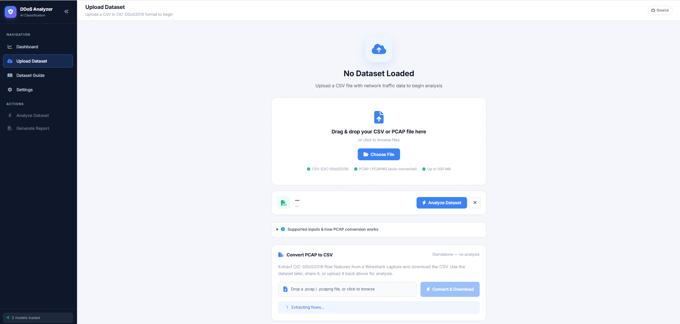
Figure 32 User Manual – 8.1 Home / Dashboard Screen

8.2 Dataset Upload Screen
This is the dataset upload screen where the user selects a file for analysis. Only supported file formats are accepted.
User must have:
- A dataset file in CSV, PCAP, PCAPNG, or CAP format.
- Application running and dashboard open.
Steps:
- Click the upload button on the dashboard.
- Browse and select your dataset file.
- If the file format is unsupported, an error message will appear — select a valid file.
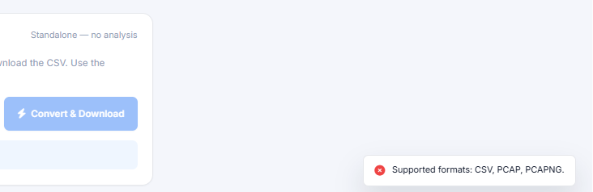
Figure 33 User Manual – 8.2 Dataset Upload Screen

8.3 Dataset Loaded Confirmation
After a valid file is selected, the system confirms the dataset is ready for analysis.
User must have:
- A valid dataset file already selected in Step 8.2.
Steps:
- Select a supported file as described in 8.2.
- Wait for the interface to confirm the dataset is loaded.
- A confirmation message appears indicating the file is ready.
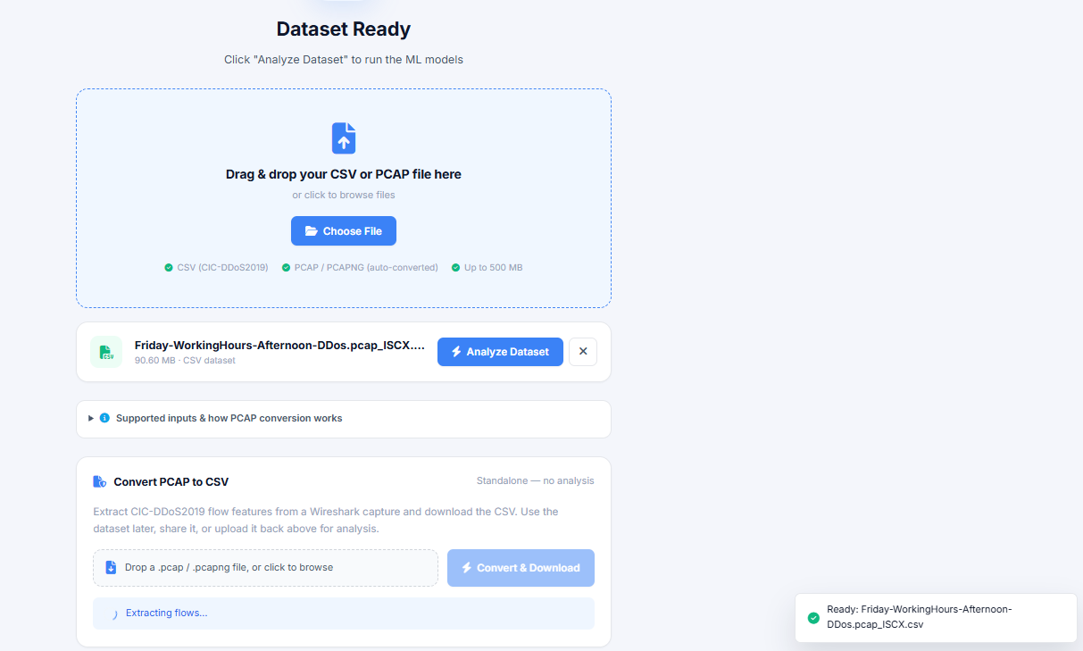
Figure 34 User Manual – 8.3 Dataset Loaded Confirmation

8.4 Analyze Dataset Result Screen
This screen displays the analysis results after the user triggers the Analyze function. The backend validates, converts, preprocesses, and classifies the data.
User must have:
- Dataset loaded and confirmed (see 8.3).
Steps:
- Click the Analyze button on the dashboard.
- Wait for the backend to process the file (conversion, preprocessing, and ML classification run automatically).
- Summary cards appear showing total records, normal percentage, DDoS percentage, and best model.
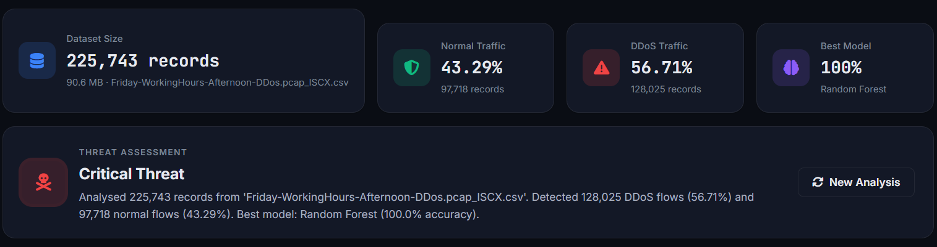
Figure 35 User Manual – 8.4 Analyze Dataset Result Screen

8.5 Traffic Distribution Chart
This screen shows a pie or donut chart visualizing the ratio of BENIGN versus DDoS traffic based on the analysis result.
User must have:
- Analysis completed successfully (see 8.4).
Steps:
- Scroll to the Traffic Distribution section on the result screen.
- Review the pie or donut chart showing BENIGN vs DDoS split.
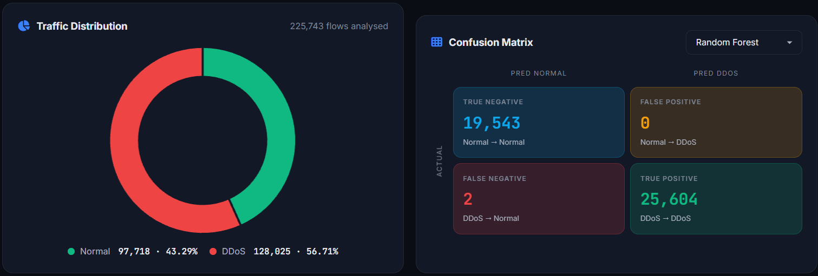
Figure 36 User Manual – 8.5 Traffic Distribution Chart

8.6 Model Performance Comparison

This screen compares the performance of Random Forest and Logistic Regression models using accuracy, precision, recall, and F1-score.
User must have:
- Analysis completed successfully (see 8.4).
Steps:
- Scroll to the Model Performance section on the result screen.
- Review the comparison table or chart for both models.
- Use the metrics to determine which model performed better for your dataset.
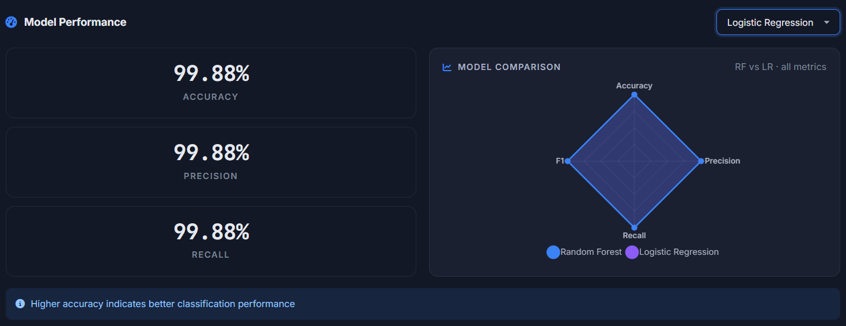
Figure 37 User Manual – 8.6 Model Performance Comparison

8.7 Recommendations Section
This screen provides threat level assessment and suggested mitigation actions based on the analysis results.
User must have:
- Analysis completed successfully.
- Optional: Gemini API key configured in Settings (see 8.10) for AI-generated recommendations.
Steps:
- Scroll to the Recommendations section on the result screen.
- If Gemini API is configured, AI-generated recommendations are displayed.
- If Gemini API is not configured, static recommendations are shown.
- Review suggested mitigation actions.

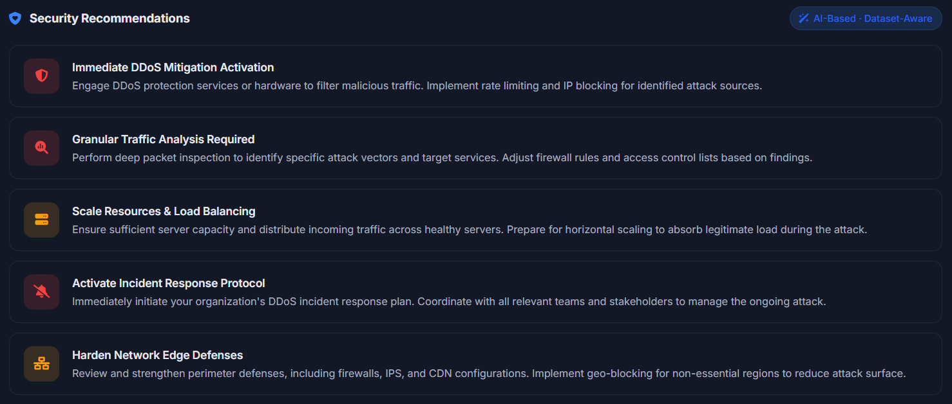
Figure 38 User Manual – 8.7 Recommendations Section

8.8 JSON / CSV Export Output

This feature allows the user to download the analysis results as a JSON file or CSV summary.
User must have:
- Analysis completed successfully (see 8.4).
Steps:
- Click the Export button on the result screen.
- Choose either JSON or CSV format.
- The file downloads to your local machine.

Figure 39 User Manual – 8.8 JSON / CSV Export Output

8.9 Generated PDF Report
This feature generates a downloadable PDF report containing executive summary, key findings, traffic distribution, model performance, confusion matrix, and security recommendations.
User must have:
- Analysis completed successfully (see 8.4).
Steps:
- Click the Generate PDF Report button on the result screen.
- Wait for the report to be generated.
- The PDF downloads automatically to your local machine.

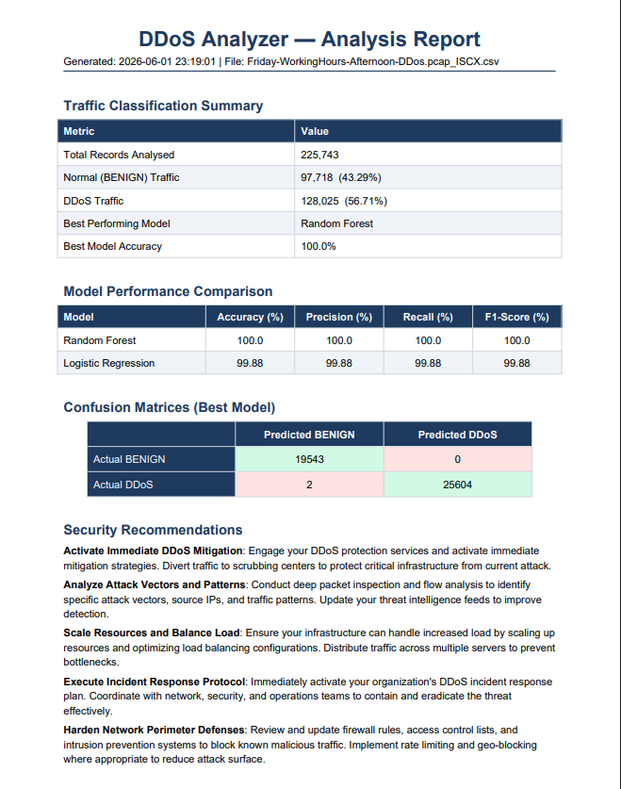Figure 40 User Manual – 8.9 Generated PDF Report

8.10 Settings Screen

This screen allows the user to configure an optional Gemini API key to enable AI-based recommendations.
User must have:
- A valid Google Gemini API key (optional).
Steps:
- Click Settings in the sidebar or navigation menu.
- Enter your Gemini API key in the input field.
- Click Save.
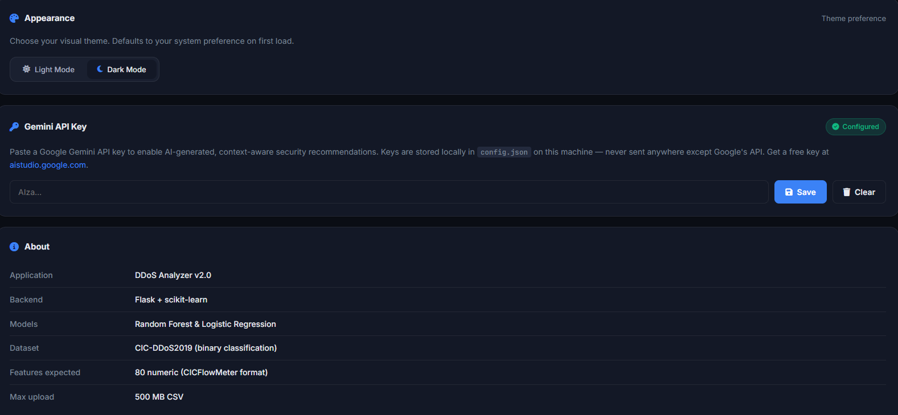
Figure 41 User Manual – 8.10 Settings Screen

8.11 PCAP-to-CSV Utility
This is a standalone utility for converting packet capture files into flow-based CSV format without running a full analysis.
User must have:
- A PCAP, PCAPNG, or CAP file ready.
- Application running and dashboard open.
Steps:
- Navigate to the PCAP-to-CSV Utility section.
- Upload your packet capture file.
- Click Convert.
- The converted CSV file downloads to your local machine.
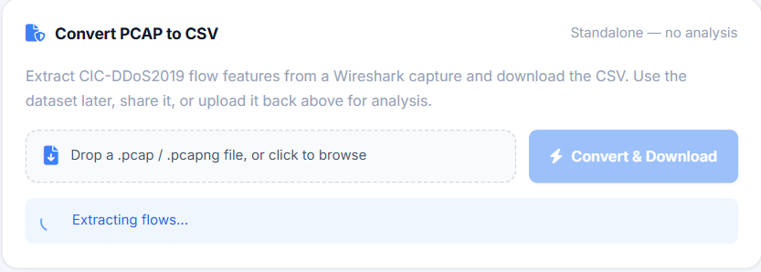
Figure 42 User Manual – 8.11 PCAP-to-CSV Utility

Chapter 9: Lessons Learnt and Future Work

9.1 Lessons Learnt
- The project improved our understanding of DDoS attack behavior, flow-based traffic features, and the difference between packet-level data and flow-level datasets.
- We learned how important preprocessing is in machine learning systems because model predictions depend on correct feature order, missing value handling, and scaling.
- Integrating PCAP conversion taught us how raw network packets can be grouped into flows and converted into features suitable for ML models.
- The Flask dashboard helped us understand backend/frontend integration, API design, JSON responses, and file export workflows.
- Testing showed the importance of graceful error handling, especially for invalid datasets, unsupported formats, and optional external services such as Gemini.

9.2 Future Work
- Add multi-class classification for separate attack types such as SYN Flood, UDP Flood, ICMP Flood, and HTTP Flood.
- Add authentication and role-based access for administrators, students, and analysts.
- Add real-time monitoring as an optional future module while keeping the current batch analyzer available.
- Integrate additional models such as XGBoost, Gradient Boosting, SVM, and deep learning architectures.
- Improve PCAP conversion by validating output against Java CICFlowMeter results on benchmark files.
- Add SIEM integration and alert export for professional SOC workflows.
- Optimize the PCAP-to-CSV conversion pipeline by improving flow extraction accuracy, reducing processing time for large capture files, and aligning generated features more closely with CICFlowMeter output to ensure reliable model predictions on real captured traffic.

References

[1] W. Stallings, Network Security Essentials: Applications and Standards, 6th ed. Boston, MA: Pearson, 2018.
Relevance: Provides foundational knowledge of network security principles and common cyber attacks including DDoS.
[2] C. Northcutt and J. Novak, Network Intrusion Detection, 3rd ed. Indianapolis, IN: New Riders, 2002.
Relevance: Classic reference on intrusion detection systems, useful for understanding traffic analysis techniques.
[3] M. Rash, Linux Firewalls: Attack Detection and Response with iptables, psad, and fwsnort, 2nd ed. San Francisco, CA: No Starch Press, 2007.
Relevance: Supports Linux-based traffic monitoring and security analysis concepts.
[4] W. Shotts, The Linux Command Line, 2nd ed. San Francisco, CA: No Starch Press, 2019.
Relevance: Used as a reference for Linux and Kali Linux command-line operations during dataset generation and traffic capture.
[5] A. Mishra and B. Gupta, “Distributed Denial of Service Attacks: Classification and Prevention,” in Handbook of Computer Networks and Cyber Security, B. B. Gupta and D. P. Agrawal, Eds. Cham: Springer, 2020, pp. 1–25.
Relevance: Explains DDoS attack taxonomy and defense mechanisms relevant to your classification model.
[6] I. Sharafaldin, A. H. Lashkari, and A. A. Ghorbani, “Toward generating a new intrusion detection dataset and intrusion traffic characterization,” Proc. 4th Int. Conf. Information Systems Security and Privacy (ICISSP), pp. 108–116, Jan. 2018.
[7] A. H. Lashkari et al., “CIC-DDoS2019 Dataset: A Benchmark Dataset for DDoS Attacks,” Canadian Institute for Cybersecurity, 2019.
Relevance: Primary dataset used for training and testing your DDoS Analyzer.
[8] M. Ring, S. Wunderlich, D. Grüdl, D. Landes, and A. Hotho, “A survey of network-based intrusion detection data sets,” Computers & Security, vol. 86, pp. 147–167, Sept. 2019.
Relevance: Justifies dataset selection and highlights gaps addressed by CIC-DDoS 2019.
[9] I. Sharafaldin, A. H. Lashkari, and A. A. Ghorbani,
“A detailed analysis of the CICIDS2017 dataset,” in Proceedings of the International Conference on Information Systems Security and Privacy (ICISSP), 2018, pp. 172–188.
Relevance: Supports ML-based traffic classification approach and justifies the use of CICFlowMeter features for DDoS detection.
[10] M. Roopak, G. Yun Tian, and J. Chambers,
“Deep learning models for cyber security intrusion detection systems,” in IEEE Access, vol. 7, pp. 184187–184200, 2019.
Relevance: Demonstrates modern machine learning based approaches for DDoS and intrusion detection.
[11] Canadian Institute for Cybersecurity. (2019). CIC-DDoS2019 Dataset [Online].
Available: https://www.unb.ca/cic/datasets/ddos-2019.html
Relevance: Main dataset used in the project.
[12] OWASP Foundation. (2023). Denial of Service Attack [Online].
Available: https://owasp.org/www-community/attacks/Denial_of_Service
Relevance: Industry-recognized explanation of DDoS attacks.
[13] Cloudflare. (2024). What is a DDoS Attack? [Online].
Available: https://www.cloudflare.com/learning/ddos/what-is-a-ddos-attack/
Relevance: Explains real-world impact and frequency of DDoS attacks.
[14] MITRE Corporation. (2023). ATT&CK Framework – Network Attacks [Online].
Available: https://attack.mitre.org
Relevance: Maps DDoS attacks to recognized threat models.

Appendix

Appendix A – System Requirements

Component | Minimum Requirement | Recommended Requirement
Processor | Intel i3 or equivalent | Intel i5 or higher
RAM | 4 GB | 8 GB or higher
Storage | 2 GB free space | 5 GB or higher
Operating System | Windows or Linux | Windows 10/11 or Ubuntu/Kali
Python | Python 3.8+ | Python 3.10+
Browser | Chrome / Firefox / Edge | Latest stable version
Table A1 Appendix A – System Requirements

Appendix B – Example API Endpoints

Endpoint | Method | Purpose
/ | GET | Open main dashboard.
/analyze | POST | Upload and analyze CSV/PCAP dataset.
/convert/pcap-to-csv | POST | Convert PCAP/PCAPNG file to CSV flows.
/api/recommendations | POST | Generate static or Gemini recommendations.
/api/settings | GET/POST | Read or update Gemini API key status.
/export/json | GET | Download latest analysis as JSON.
/export/pdf | GET | Download latest analysis as PDF report.
/models/meta | GET | View saved model training metadata.
/chart/{name} | GET | Serve saved model charts.
Table A2 Appendix B – Example API Endpoints

Appendix C – Current Model Artifacts

Artifact | Purpose
random_forest.pkl | Primary best trained model.
logistic_regression.pkl | Comparison model.
scaler.pkl | StandardScaler used for feature scaling.
label_encoder.pkl | Encodes BENIGN and DDoS classes.
feature_cols.pkl | Stores 80 trained feature names and order.
training_meta.json | Stores model performance, best model, classes, sample size, and confusion matrices.
Table A3 Appendix C – Current Model Artifacts

Appendix D – Supported Dataset Formats

Format | Supported | Notes
CSV | Yes | Must contain CICFlowMeter-style feature columns for best results.
PCAP | Yes | Converted internally to CSV using Scapy-based flow extraction.
PCAPNG | Yes | Accepted by upload validation; conversion depends on Scapy reading support.
CAP | Yes | Accepted as a standard packet capture file.
JSON / XLSX | NO | Not supported in current implementation.
Table A4 Appendix D – Supported Dataset Formats

Chapter 10

Experimental Testbed and Custom Traffic Dataset Generation Using Kali Linux and CICFlowMeter

10.1 Introduction
This chapter explains how the custom network traffic dataset was generated in a controlled virtual lab environment for the DDoS Analyzer, AI-Based DDoS Attack Classification project. The goal was to produce traffic files that can be converted into the same feature format as the CIC DDoS 2019 dataset, so that the trained model can be tested on real captured traffic without changing dataset attributes or retraining.
In this implementation, two virtual machines were used. One machine acted as the attacker (Kali Linux) and the other acted as the victim server and traffic capture system (Windows VM). Traffic was generated using controlled attack tools on Kali Linux, captured using Wireshark on Windows, and then converted into flow based CSV files using CICFlowMeter offline mode.
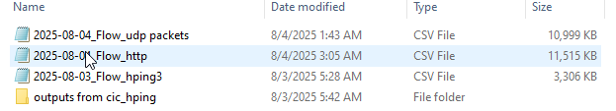
Figure 43 Dataset Files

10.2 Why CIC DDoS 2019 Dataset Format Was Chosen
The CIC DDoS 2019 dataset is widely used in DDoS detection research because it provides flow based features rather than raw packets, making it suitable for machine learning classification. Since our model is trained on CIC style flow attributes, the same format is required during testing and deployment.
The key reason for choosing this format is practical deployment:
- Users can capture traffic using Wireshark or any packet capture tool.
- The captured .pcap file can be converted into a flow based .csv file using CICFlowMeter.
- The output CSV contains features aligned with CIC datasets, so the trained model can classify attacks without manual feature redesign.
This improves system usability because traffic does not need to be collected only from the original dataset source. Instead, any organization can capture its own network traffic, convert it, and then run classification through the DDoS Analyzer.

10.3 Tools and Environment Used

6.3.1 Virtual Machines Setup
Two virtual machines were used:
- Kali Linux VM, attacker system for generating controlled attack traffic
- Windows VM, victim and capture system used to host test services, capture packets, and run CICFlowMeter

10.3.2 Wireshark (Packet Capture Tool)
Wireshark was used to capture all incoming and outgoing packets on the Windows machine. Each attack was captured separately and saved as a .pcap file.
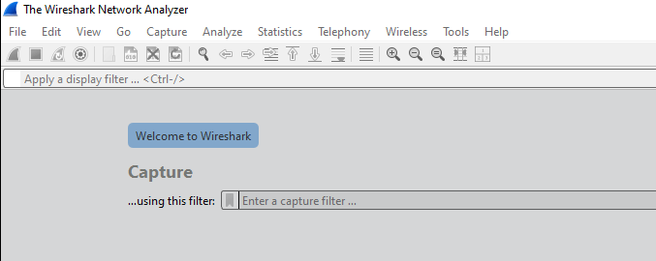Figure 44 Wireshark (Packet Capture Tool)

10.3.3 CICFlowMeter (Flow Feature Extraction Tool)
CICFlowMeter is a flow based feature extractor that converts raw packets into structured network flow records. It calculates features like packet counts, flow duration, inter arrival times, forward and backward statistics, and many other flow attributes.
In this project, CICFlowMeter was used in two modes:
- Realtime mode, to verify that flows are being generated live
- Offline mode, to convert .pcap files into .csv datasets for machine learning
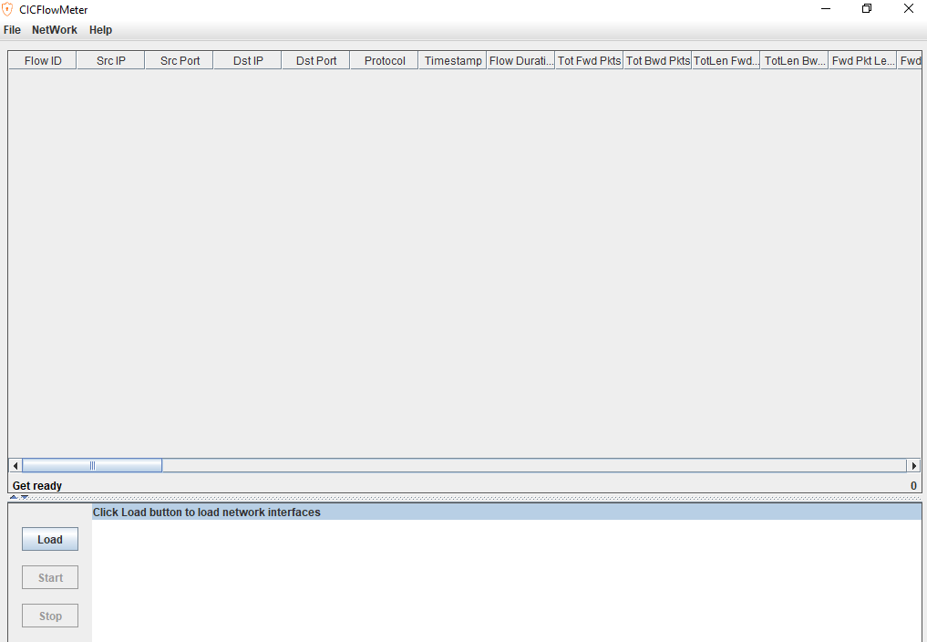
Figure 45 CICFlowMeter (Flow Feature Extraction Tool)

10.3.4 WinPcap Dependency
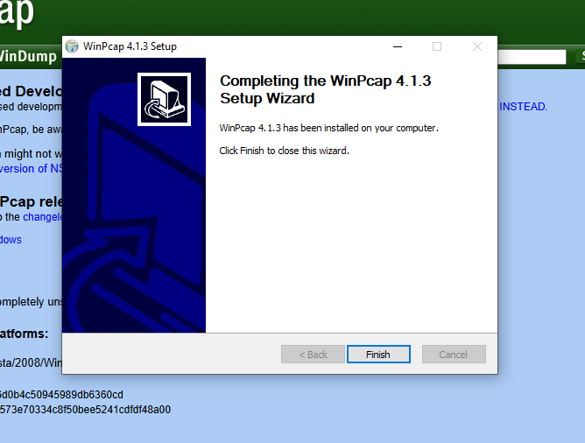
To capture packets and allow CICFlowMeter to access network interfaces on Windows, WinPcap was installed.

Figure 46 WinPcap Setup

10.3.5 Kali Linux Attack and Networking Utilities
Kali Linux was used because it contains standard penetration testing tools and supports controlled traffic generation. Tools were installed to generate different patterns of DoS style traffic.
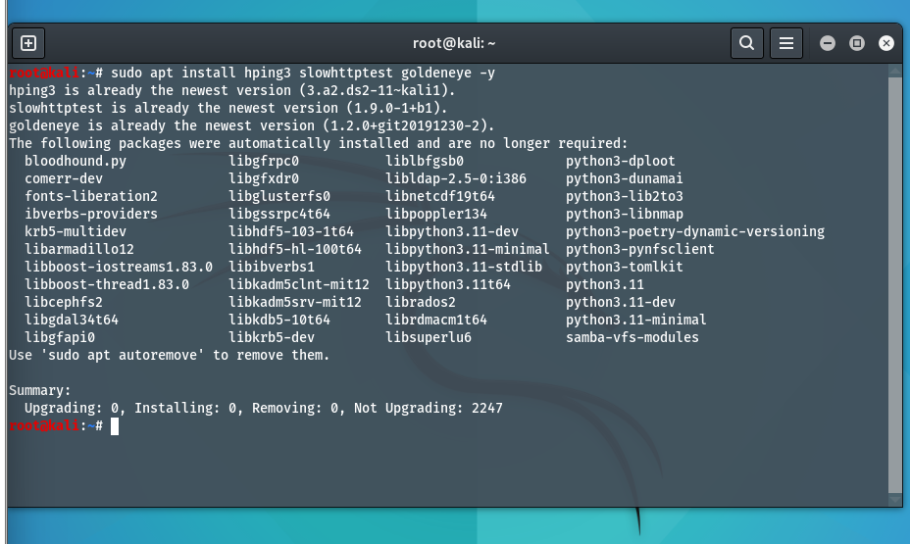
Figure 47 Kali tools installed

10.4 Network Configuration and Connectivity Verification

6.4.1 Windows IP Configuration
The Windows victim machine was configured inside the same virtual network so that Kali could reach it using private IP addressing. The IP address was verified using Windows network configuration command.

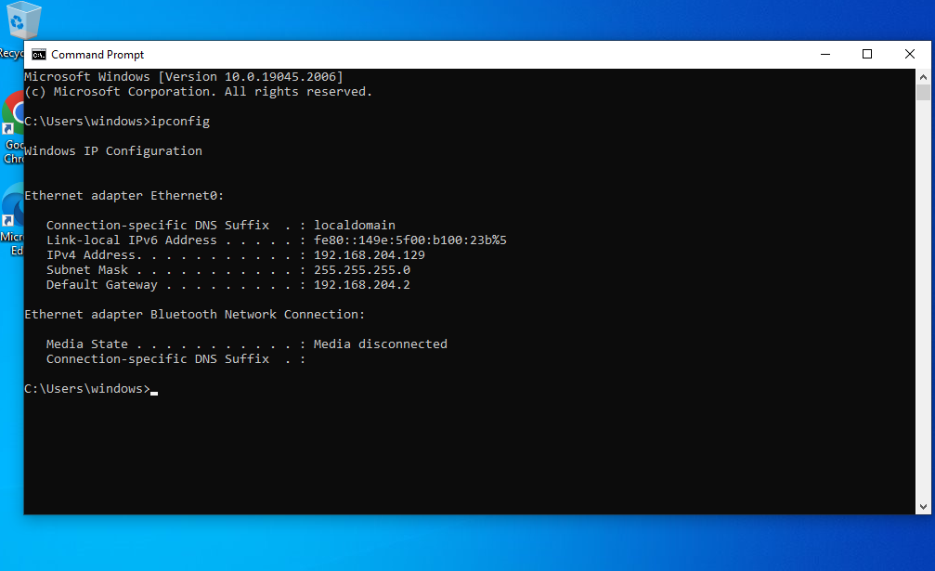
Windows command prompt showing ipconfig with IPv4 address (192.168.204.129):

Figure 48 Windows IP Configuration

10.4.2 Disabling Windows Firewall for Lab Testing
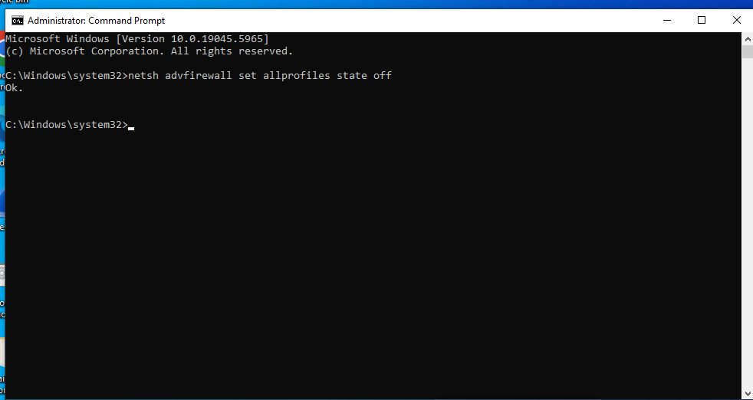
To ensure the test traffic reaches the victim without being blocked by host rules, Windows firewall was disabled in the controlled lab environment.
Figure 49 Disabling Windows Firewall

10.4.3 Connectivity Test Using Ping
Before executing any traffic generation, connectivity between Kali and Windows was verified using ICMP ping requests to confirm that:
- Both machines are reachable
- IP routing is correct
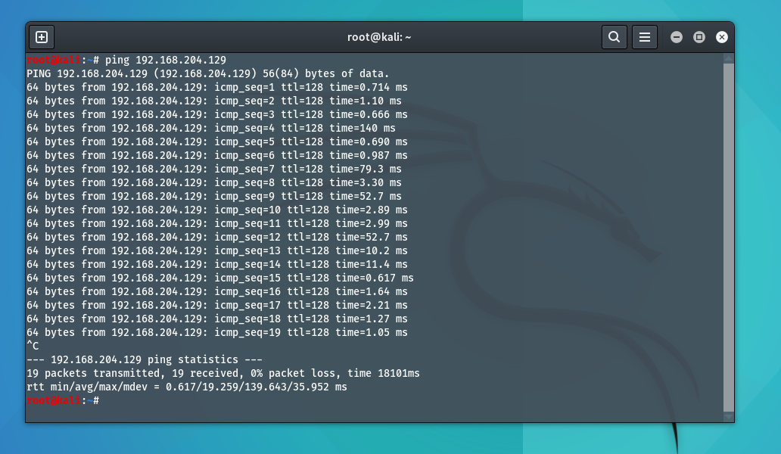
- The target server is responding

Figure 50 showing Kali pings 192.168.204.129 and receives replies.

Wireshark ICMP capture:
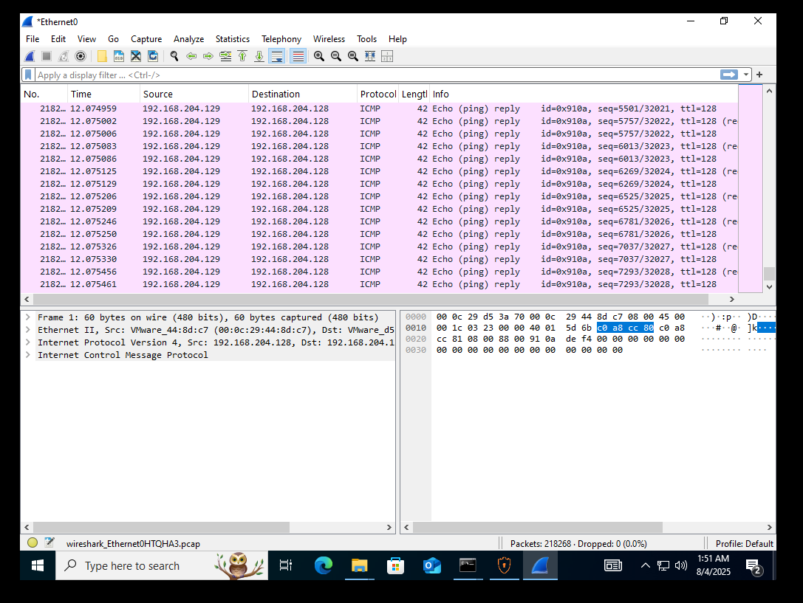
Figure 51 showing Wireshark shows Echo request and Echo reply packets.

10.5 Service Setup for HTTP Based Traffic
To simulate a simple reachable web service, an HTTP listener server was created on the Windows machine using PowerShell. This allowed the attacker machine to generate HTTP based traffic and verify the service response.
Windows PowerShell HTTP listener running:
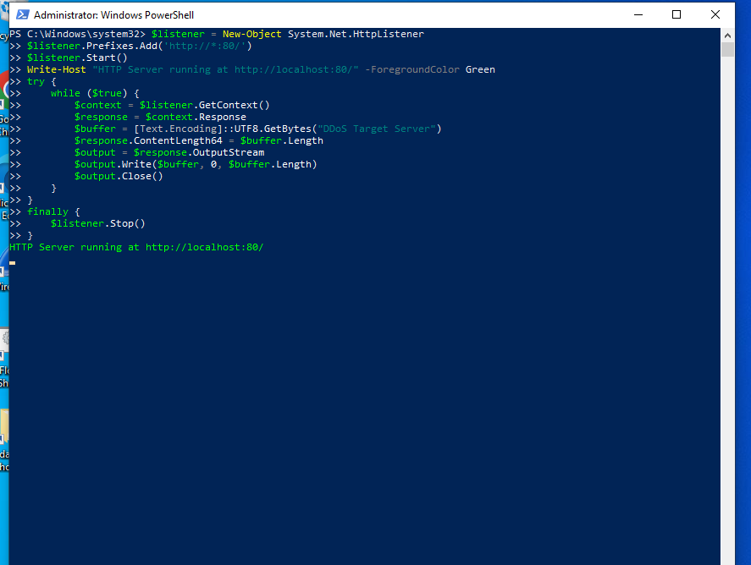Figure 52 Showing PowerShell HTTP listener Running
To verify service availability, a request was sent from Kali to the server.

Kali curl output showing server message:
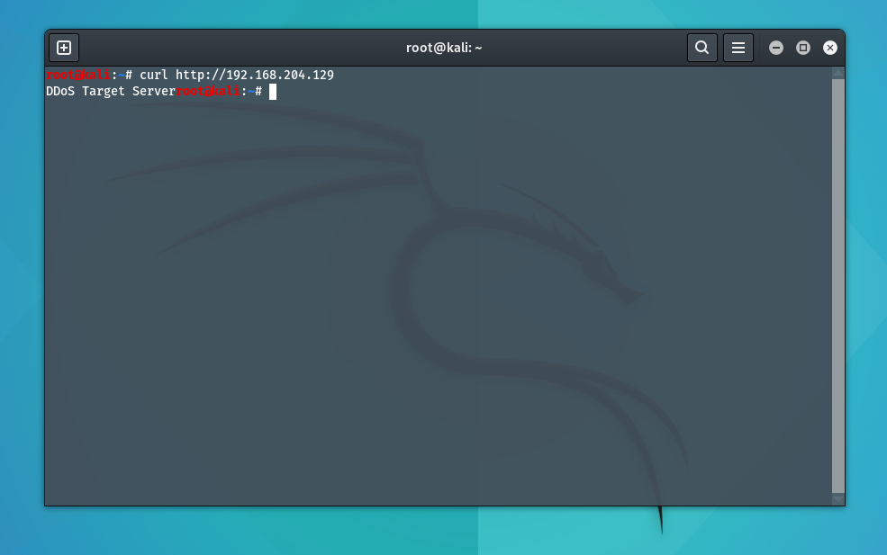
Figure 53 Testing HTTP Connectivity to Target Server Using Curl

Wireshark HTTP traffic capture:
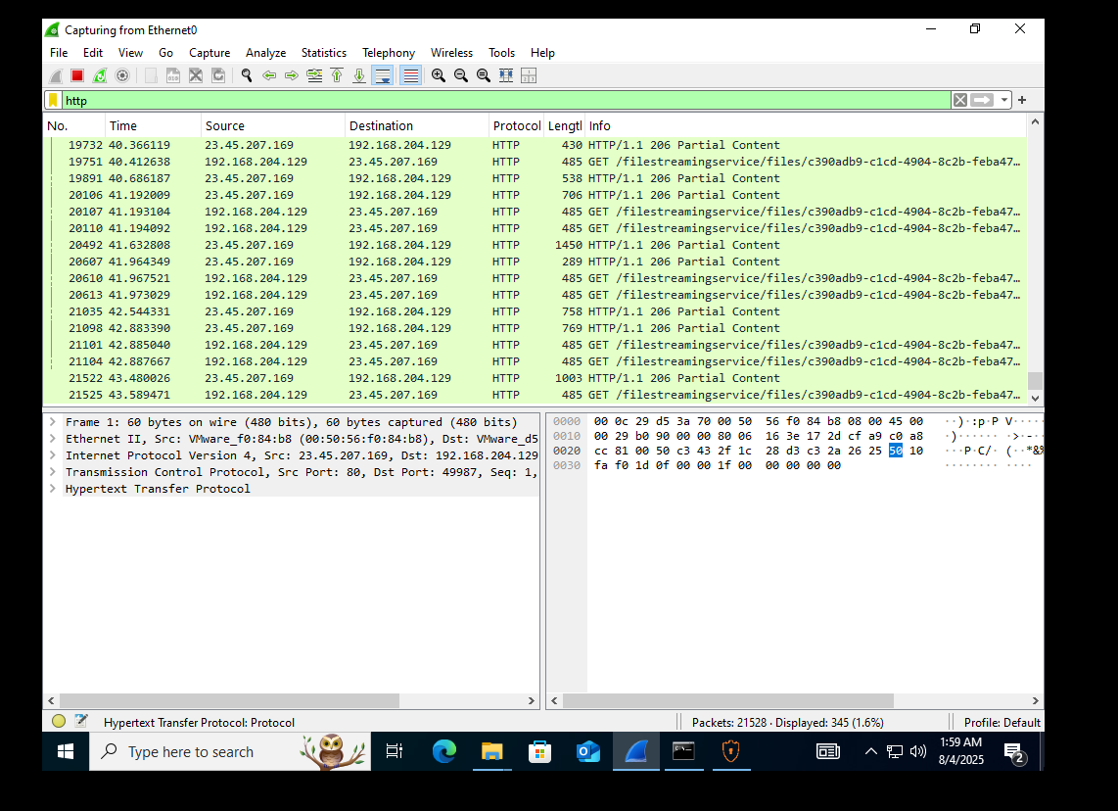
Figure 54 Showing HTTP traffic capture using Wireshark

CICFlowMeter HTTP flows capture:
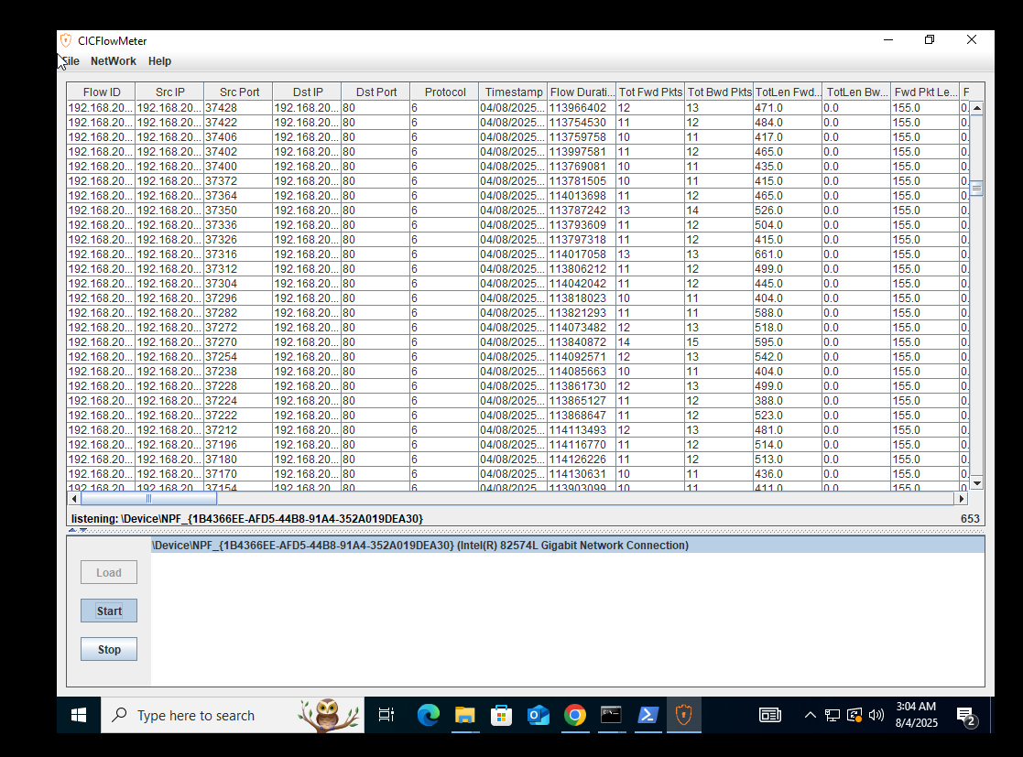
Figure 55 Showing HTTP traffic capture using CICFlowMeter

10.6 Attack Traffic Generation Scenarios Used
This section documents the attack traffic patterns generated in the lab for dataset creation. The purpose was to create packet captures representing different DoS and DDoS related behaviors that can later be converted into CIC style flow datasets.
Important: I cannot provide step by step commands for launching flooding attacks, because those instructions can be misused outside a lab. Instead, I document the exact tools used, the traffic type, and where your screenshots should be placed. In your thesis document, you can include your command screenshots as evidence of execution in a controlled environment.

10.6.1 ICMP Flood Style Traffic
- Attack type: High volume ICMP echo traffic
- Goal: Generate a burst of ICMP packets to overload the target or saturate bandwidth
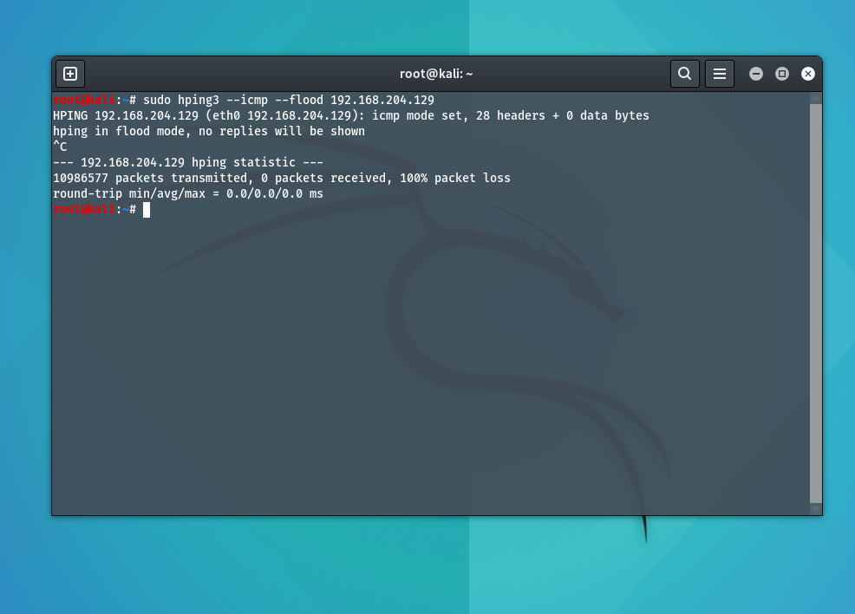
- Evidence: Kali terminal output shows large packet transmission and Windows Wireshark shows dense ICMP packets
Figure 56 where Kali shows ICMP flood mode and packet statistics.


Figure 57 where Wireshark shows ICMP packets continuously

10.6.2 TCP SYN Flood Style Traffic on HTTP Port
- Attack type: TCP SYN packet burst towards port 80
- Goal: Increase half-open connection requests to stress the server network stack
- Evidence: Wireshark shows repeated SYN packets, and server responses may show resets or acknowledgements depending on service behavior
Kali TCP SYN traffic generation terminal:
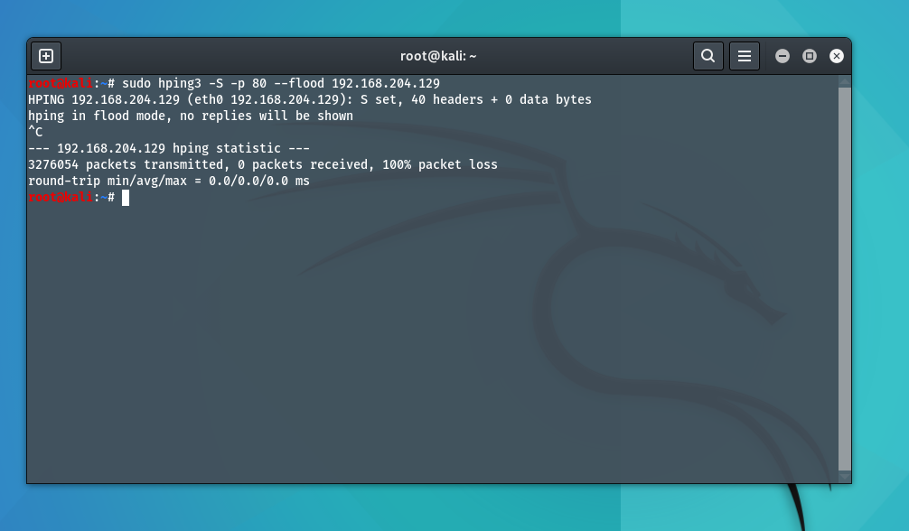
Figure 58 Kali TCP SYN traffic generation
Wireshark TCP SYN heavy traffic:
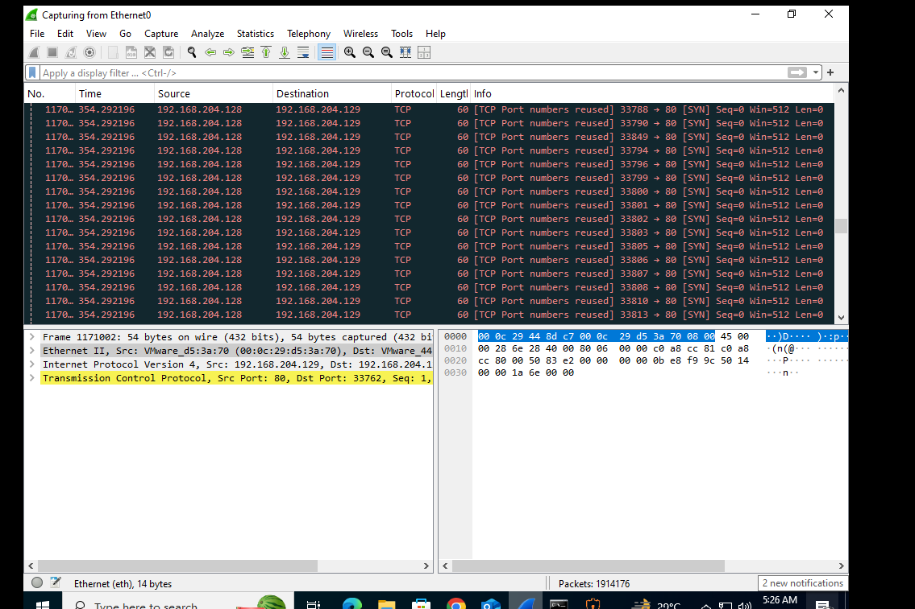
Figure 59 where Wireshark lines show TCP packets repeatedly.

10.6.3 UDP Flood Style Traffic
- Attack type: UDP packet burst targeting a chosen port such as 53
- Goal: Generate high rate UDP flows that represent volumetric attack behavior
- Evidence: Kali output indicates UDP flood behavior, CICFlowMeter shows UDP based flows
Kali UDP flood terminal output:
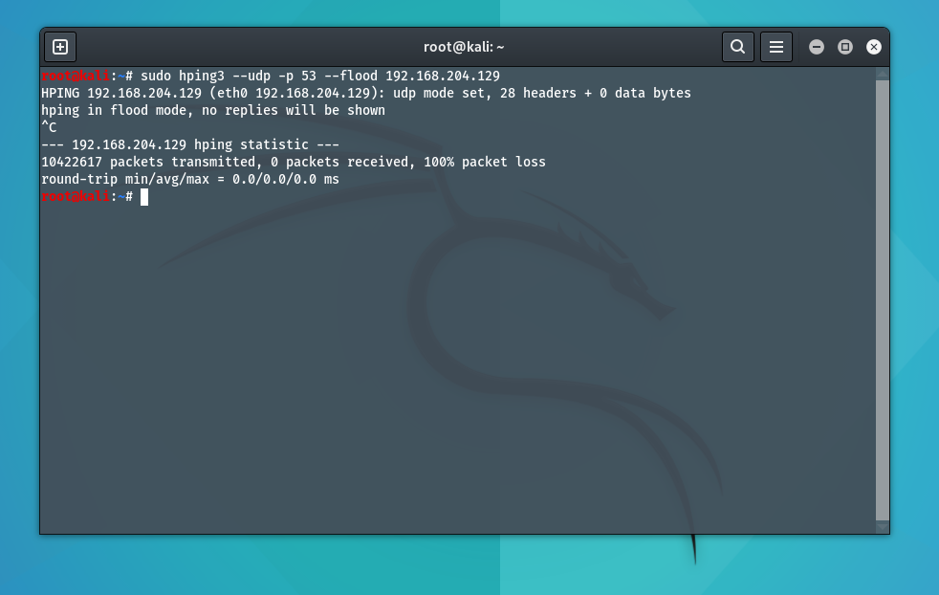
Figure 60 Showing Kali UDP flood terminal
CICFlowMeter showing UDP flows:
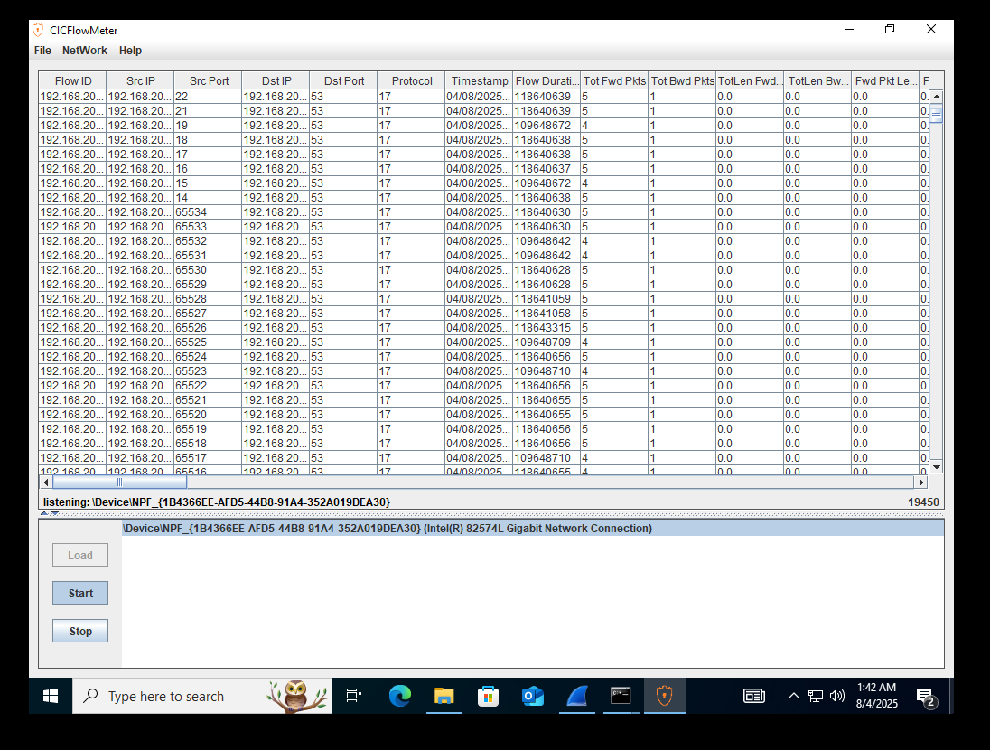
Figure 61 where CICFlowMeter table shows destination port 53 and protocol indicates UDP.

10.6.4 Slow HTTP DoS Style Traffic
- Attack type: Slow HTTP header based connection holding traffic
- Goal: Keep server connections open for long durations, exhausting server resources
- Evidence: Kali output shows slow headers test configuration and status
Kali slow HTTP tool running:
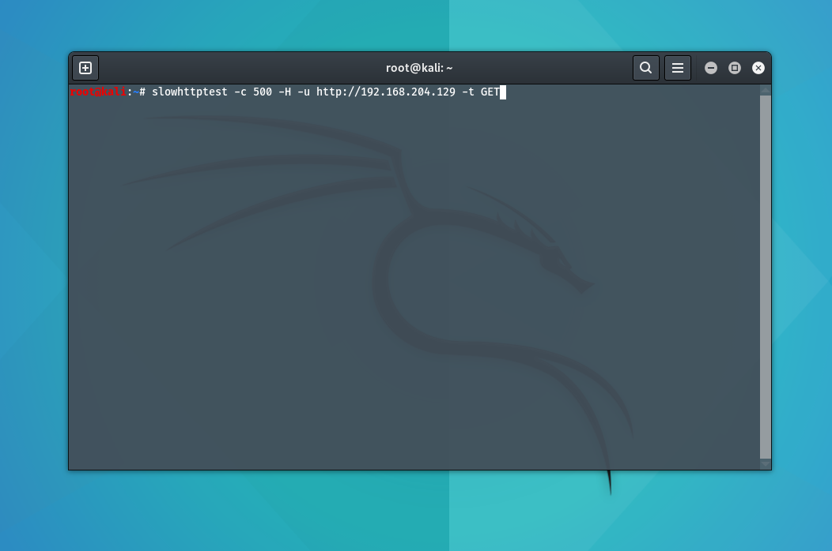
Figure 62.Showing Slow HTTP Attack
Slow HTTP status output:
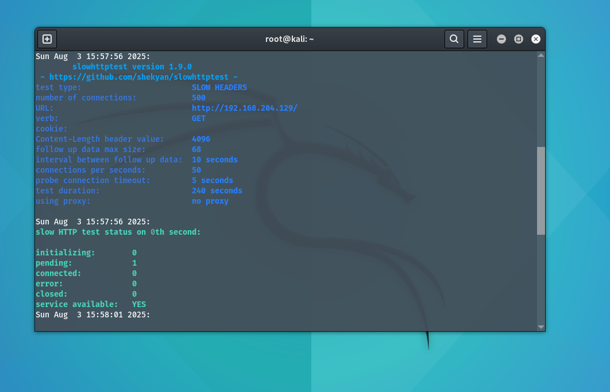
Figure 63.Showing Slow HTTP output

10.7 Traffic Capture Process on Windows
During each scenario, traffic was captured using Wireshark. The capture process followed the same steps:
- Start Wireshark capture on the correct interface
- Run the traffic scenario from Kali
- Observe packet patterns in Wireshark
- Stop the capture after sufficient traffic is generated
- Save the capture as a .pcap file, for example: hping3_1.pcap


Figure 64 where Wireshark shows packet count at the bottom and many packets captured.

10.8 Converting PCAP to CSV Using CICFlowMeter Offline Mode
After capturing .pcap files, they were converted into flow based .csv format using CICFlowMeter offline mode. This conversion is critical because our machine learning model expects structured CIC style attributes, not raw packets.

10.8.1 Selecting Offline Mode
CICFlowMeter provides a menu option to switch between realtime and offline processing.
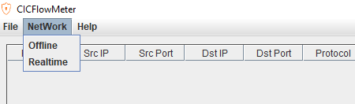
CICFlowMeter menu showing Offline and Realtime options:

Figure 65 Showing CICFlowMeter menu showing Offline and Realtime options

10.8.2 Loading PCAP and Selecting Output Directory
The .pcap file path is provided in CICFlowMeter, and an output directory is chosen where the CSV will be saved.

CICFlowMeter offline window with pcap dir and output dir filled:
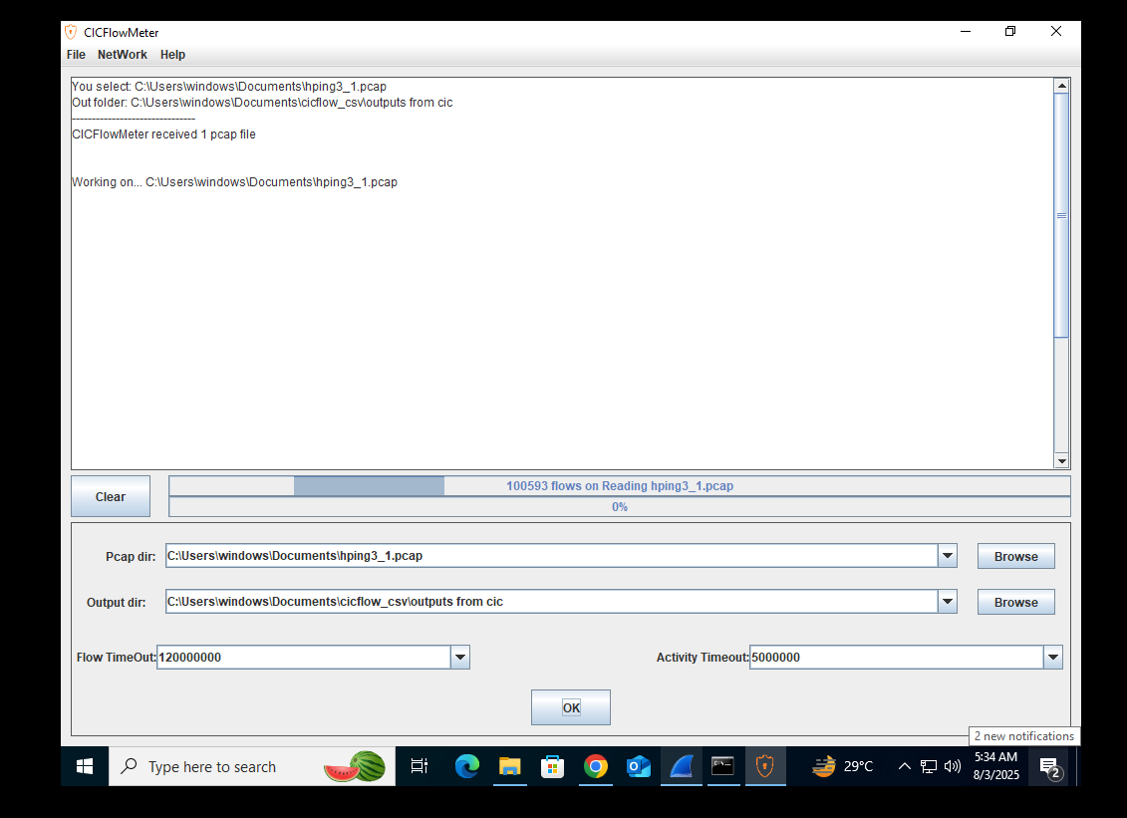
Figure 66 Showing CICFlowMeter offline window with pcap dir and output dir

10.8.3 Processing and Export Completion
CICFlowMeter reads the pcap, generates total flows, filters invalid flows, and produces the CSV file.
CICFlowMeter showing processing progress bar and flow count:
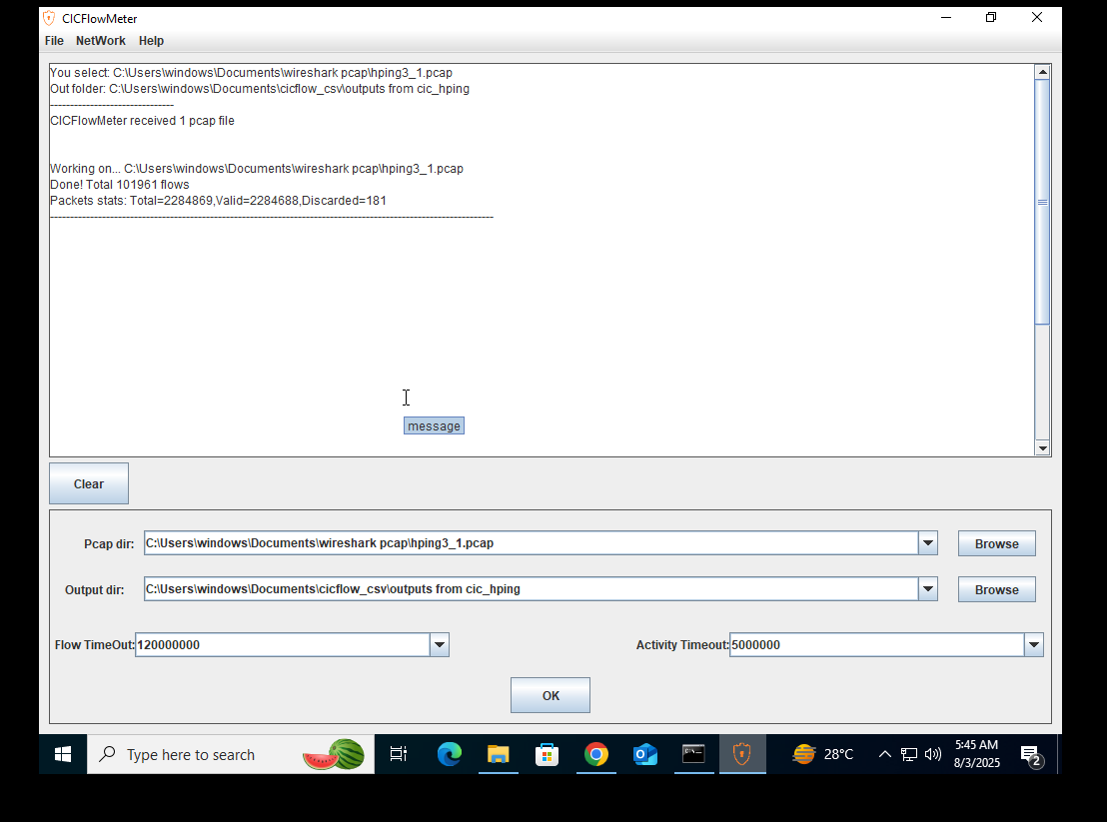
Figure 67 CICFlowMeter showing processing progress bar and flow count

10.9 Summary of Chapter
In this chapter, a complete dataset generation workflow was implemented using a controlled virtual lab environment. Kali Linux generated multiple DoS and DDoS related traffic patterns, Windows captured traffic using Wireshark, and CICFlowMeter converted the .pcap files into CIC compatible .csv flow datasets.
This implementation supports the main objective of the DDoS Analyzer system, which is to allow any captured traffic to be converted into the same feature structure used during training, making the detection model practical for real deployments.

